**Science 9 – Introduction to Current and Circuits (Current Electricity Notes 1)**

**Static Electricity**

* ___________ that builds up on an object.
* This charge is ‘__________________” in an uncontrolled way (when you rub your feet on the carpet and then shock someone, or like lightning).

**Current Electricity**

* Charge is used in a ___________________ way – by allowing it to travel through a __________________.
* A circuit is a ___________ for _______________ to flow through.
* The charges flow from an energy source such as a _________________ to a device that uses the energy.

**Parts of a Circuit**

**Source**

* 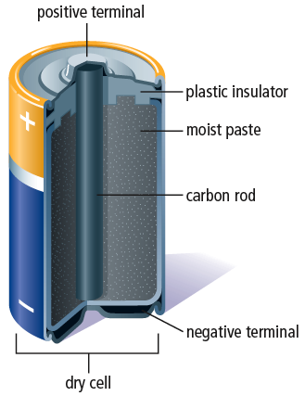The energy source in a circuit provides ______________________.
* Wall plugs: electrical energy is delivered by _____________________.
* _______________________________: energy from _______________ ____________________ is turned into electrical energy
* A _________________________ is a combination of one or more cells.

**Load**

* A load is a device that _________________ electrical energy into ______________________.
  + 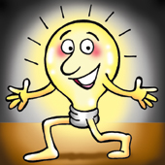A toaster converts electrical energy into ___________ energy.
  + A motor converts electrical energy into ______________ energy (the energy of movement).
  + Light bulb converts electrical energy into _____ energy and ______ energy.

**Switch**

* The switch controls the __________ of ______________________.
* C:\Users\Nindi\AppData\Local\Microsoft\Windows\Temporary Internet Files\Content.IE5\4REO0QLP\MC900360506[1].wmfWhen a switch is ________, the pathway is ____________________ so no charge flows through the circuit.
* When a switch is ________ the path is _____________ and current does flow through the circuit.

|  |  |
| --- | --- |
| **PART OF CIRCUIT** | SYMBOL |
| Conducting Wire |  |
| Cell |  |
| Two-Cell Battery |  |
| Open Switch |  |
| Closed Switch |  |
| Light Bulb (lamp) |  |
| Ammeter |  |
| Voltmeter |  |
| Resistor |  |

**Drawing Circuit Diagrams**

* When we draw diagrams of circuits, the different parts are represented by the symbols in the table on the right.

**Example 1**

*A simple circuit with a single cell, a switch and a light bulb.*

**Series and Parallel Circuits**

In circuits, it is possible to have 2 different pathways:

|  |  |
| --- | --- |
| **Series**: current must travel through _____________________________ in circuit | **Parallel:** current ________ and some will go through each device |

**Example 2**

*A circuit consisting of a battery of* ***2 cells*** *in series, an open* ***switch****, and* ***2 lamps*** *in parallel.*