**Science 9 – What is Static Electricity? (Static Electricity Notes 1)**

**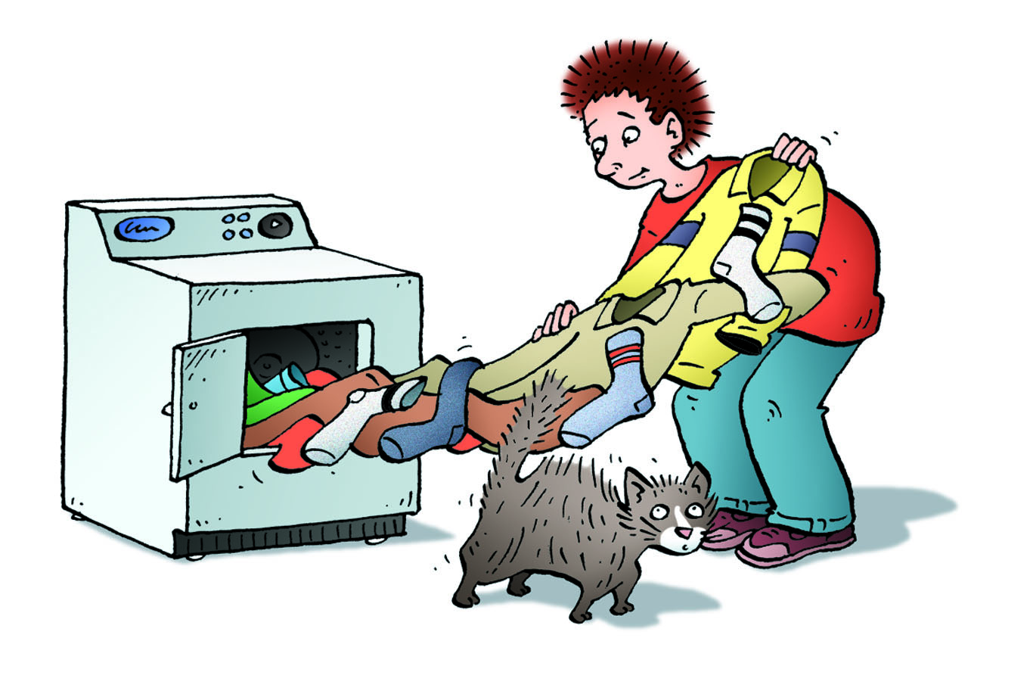**

* The effects of static electricity are all around you
  + e.g. clothes from dryer, lightning, \_\_\_\_\_\_\_\_\_\_\_\_\_\_\_ from metal doors
* A **static charge** is an electric charge that is \_\_\_\_\_\_\_\_\_\_\_\_\_\_\_\_\_\_\_ (not moving).
* Eventually static charges are **\_\_\_\_\_\_\_\_\_\_\_\_**, or lost, to other objects or to the air.
* The study of static electric charge is called **\_\_\_\_\_\_\_\_\_\_\_\_\_\_\_\_\_\_\_\_**.
* We cannot see electric charge directly. Instead, we observe its effects:
  + e.g. \_\_\_\_\_\_\_\_\_\_\_\_\_ is a discharge of static electricity

|  |
| --- |
| **Types of Electric Charge**   * bc9_u3c7_p256Benjamin Franklin showed that lightning is a form of \_\_\_\_\_\_\_\_\_\_\_\_\_\_\_\_\_ by flying a kite during a thunderstorm. * Because of experiments by Franklin and others, it was determined that materials can be:   + Positively charged (+)   + Negatively charged (-)   + Uncharged or neutral (0) |

|  |
| --- |
| **Atomic Structure and Electric Charge**   * **bc9_u3c7_p250_fig7_2**Recall from chemistry that all matter is made up of tiny particles called ­­­­­­\_\_\_\_\_\_\_. * Three smaller (subatomic) particles make up the atom: \_\_\_\_\_\_\_\_\_\_\_, neutrons and \_\_\_\_\_\_\_\_\_\_\_\_. * Protons and neutrons are strongly attached to the nucleus but electrons are outside of the nucleus are can be easily \_\_\_\_\_\_\_\_\_\_\_ or \_\_\_\_\_\_\_\_\_\_. * Neutral objects are ones with \_\_\_\_\_\_\_\_\_\_\_\_\_\_ numbers of protons and electrons. * Charged objects have acquired a negative or positive charge depending on whether they \_\_\_\_\_\_\_\_\_\_\_\_\_ (-) or \_\_\_\_\_\_\_\_\_\_\_\_\_\_\_ (+) electrons. |

|  |
| --- |
| **Laws of Electric Charges**   * The law of electric charges states that “like charges ­­­­­­\_\_\_\_\_\_\_\_\_\_\_ and unlike charges \_\_\_\_\_\_\_\_\_” * Two positive objects push away from each other * Two \_\_\_\_\_\_\_\_\_\_\_ objects push away from each other * One positive and one negative will \_\_\_\_\_\_\_\_ each other |

|  |
| --- |
| **Electrostatic Series**   * A list of materials in order of increasing attraction for electrons. * It shows you which object is more likely to \_\_\_\_\_\_\_\_\_\_ or \_\_\_\_\_\_\_\_\_ electrons when two objects are rubbed against each other due to \_\_\_\_\_\_\_\_\_\_\_\_\_\_ of electrons |

|  |
| --- |
| **Static Electric Charge Examples**   * C:\Documents and Settings\gill_narinder\Local Settings\Temporary Internet Files\Content.IE5\PC1XE12U\MC900413632[1].wmfAn amber rod develops a \_\_\_\_\_\_\_\_\_\_\_\_ charge when rubbed with wool or fur. * A plastic rod develops a \_\_\_\_\_\_\_\_\_\_\_\_\_ charge when rubbed with cotton * When objects are rubbed against each other, they can transfer charge from one to another   + only \_\_\_\_\_\_\_\_\_\_\_\_\_\_\_\_ move around – not \_\_\_\_\_\_\_\_\_\_\_\_\_\_\_ * C:\Documents and Settings\gill_narinder\Local Settings\Temporary Internet Files\Content.IE5\PC1XE12U\MC900383972[1].wmfSome materials are more likely than others to give up electrons.   + Ex. When acetate (a type of plastic used in overhead transparencies) is rubbed with paper, the acetate develops a **\_\_\_\_\_\_\_\_\_\_\_** ( ) charge and the paper develops a **\_\_\_\_\_\_\_\_\_\_\_\_\_** ( ) charge.   + Example: if rubber was rubbed with silk...silk is more likely to \_\_\_\_\_\_\_\_\_\_\_ electrons so it would become **\_\_\_\_\_\_\_\_\_\_\_\_\_** charged, giving electrons to the rubber and making it **\_\_\_\_\_\_\_\_\_\_\_\_** charged. |

|  |
| --- |
| **Attraction of Neutral Objects to Charged Objects**   * When a charged object is brought near to a \_\_\_\_\_\_\_\_\_\_\_\_\_ object, the electrons in the neutral object \_\_\_\_\_\_\_\_\_\_\_\_\_ so that the end of the neutral object is \_\_\_\_\_\_\_\_\_\_\_\_\_\_ to the charged object. * Although there is a slight shift of charges within the neutral object, it \_\_\_\_\_\_\_\_\_\_\_\_\_\_\_\_\_ gain or lose electrons and is still neutral. * This charging effect is known as **induced charge separation**.   Diagram  Description automatically generated |