Science 9 – Current (Current Electricity Notes 2)

What is Current?
Current is the __________________________________________ through a circuit.

An electrochemical cell (battery) uses chemical reactions to move electrons. This creates a “potential difference” between two ends of the battery:
- Positive terminal is positively charged
- Negative terminal is negatively charged and has an excess of _______________.
When a circuit connects the two terminals, current flows through the wire.
- Electrons are repelled by the _______________ terminal and are attracted by the _________________ terminal.
- Electrons cannot move through ___________________________, but they can definitely move through a _______________________________!

Calculating Current
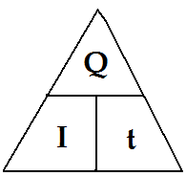
Current (I) is the amount of charge (Q) that passes a point in a circuit every second (t):
$$I=$$
- I: is the symbol for _________, measured in Amperes (A)
- Q: is the symbol for charge, measured in _____________ (C)
- t: is time, measured in seconds (s)
Example #1  What is the current in a wire if 25 C of charge passes by a point in 5 seconds? | Example #2  If the current in a wire is measured to be 12 A, how much charge passes by a point in the circuit every minute?
Example #3  A current of 64 mA is equivalent to ____________________ A. | Example #3  A current of 0.0028 A is equivalent to ____________________ mA.

Measuring Current  Current is measured by a device called an __________________.  - Symbol in circuit diagrams:  Typical amounts of current:  - In a light bulb is 1A  - In a TV is 4A  - In a car starter is 500 A | Complete this circuit diagram by adding a light bulb and an ammeter.

Series and Parallel Circuits
In a circuit, devices (such as light bulbs or batteries) can be placed in two different ways.
SERIES  - When devices are placed in series, the current goes through a ___________________ through all devices.  - In this circuit, there is only one path and the _____________ goes through the two light bulbs in the series.  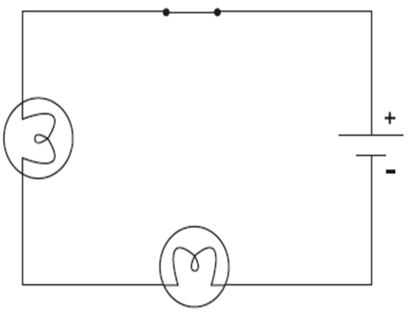 | PARALLEL  - When devices are placed in parallel, there are 2 or ____________________ that the current can take  - Current ____________: some electrons go through one device, and some go through the other(s).  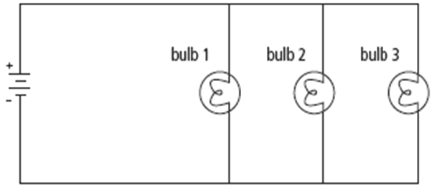
Decide whether each circuit is Series, Parallel, or a Combination of the two.
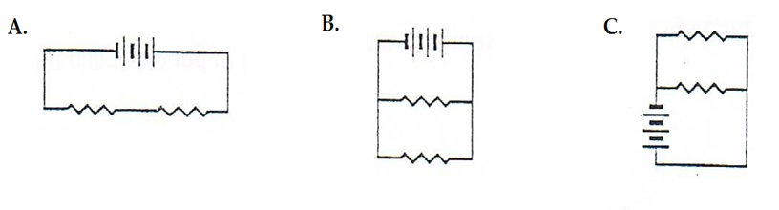
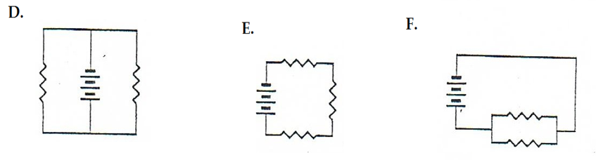

Calculating Current in SERIES  - Current (I)  - Measured in Amperes (A)  - When you place an Ammeter in SERIES (SIDE BY SIDE) the current ________________________  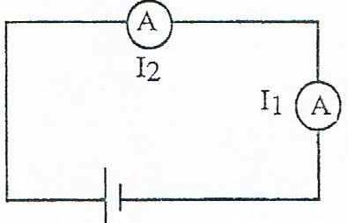  - Series:  $$I_{Total}=$$ | Calculating Current in PARALLEL  - Current (I)  - Measured in Amperes (A)  - When you place an Ammeter in PARALLEL (OPPPOSITE FROM EACHOTHER), you ______ the current to find a total.  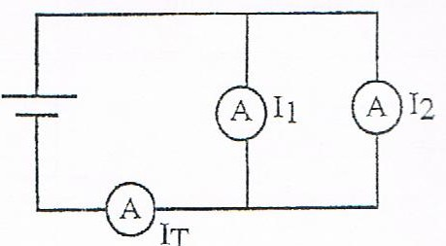  - Parallel:  $$I_{Total}=$$
Example #4
Find the total current for the following circuit.

Example #5
Find the total current for the following circuit.

Example #6
How long does it take 40 C of charge to pass by a point if the current in the circuit is 0.76 A ?

