Science 9 – Voltage (Current Electricity Notes 3)

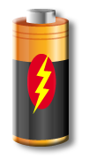
Energy is Required to do Work
- In science, energy is measured in “Joules” (J)
- Your phone battery holds ~ _________________ of energy‼!
- Fun fact: a food “Calorie” is equal to 4184 J, so an egg holds ______________ of energy!
- Energy is required to do work (e.g. lighting up a bulb, heating up a stove).
- Energy sources provide electrons with energy to do __________ (e.g. lighting up a bulb, heating up a stove).

Understanding Potential Energy
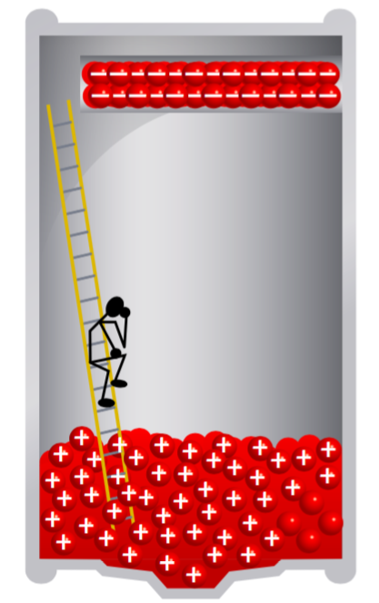
Voltage Gain
- Batteries give electrons a certain amount of _______________________________, also known as _____________ (V).
- E.g. an AA or AAA battery has a potential energy difference of 1.5 V between its two terminals, so we call it a 1.5 V battery.
Voltage Drop
- When electrons go through a ____________ (e.g. resistor, light bulb), they _____________ __________________. Some loads may use more energy than others.
- On its journey around the circuit, an electron must use ______________________________________________ before it returns to the positive terminal of the battery.

Measuring Changes in Potential Energy
The voltage difference between two points on a circuit can be measured using a voltmeter.  - Voltmeter symbol in circuit diagrams:  - A voltmeter is always connected across the device, in _______________. | 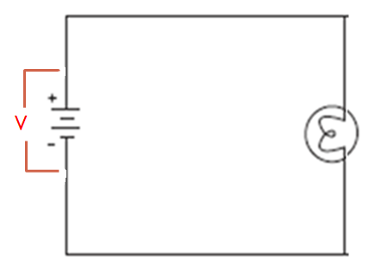  Add a voltmeter to this circuit diagram to show how you would measure the voltage of the battery.

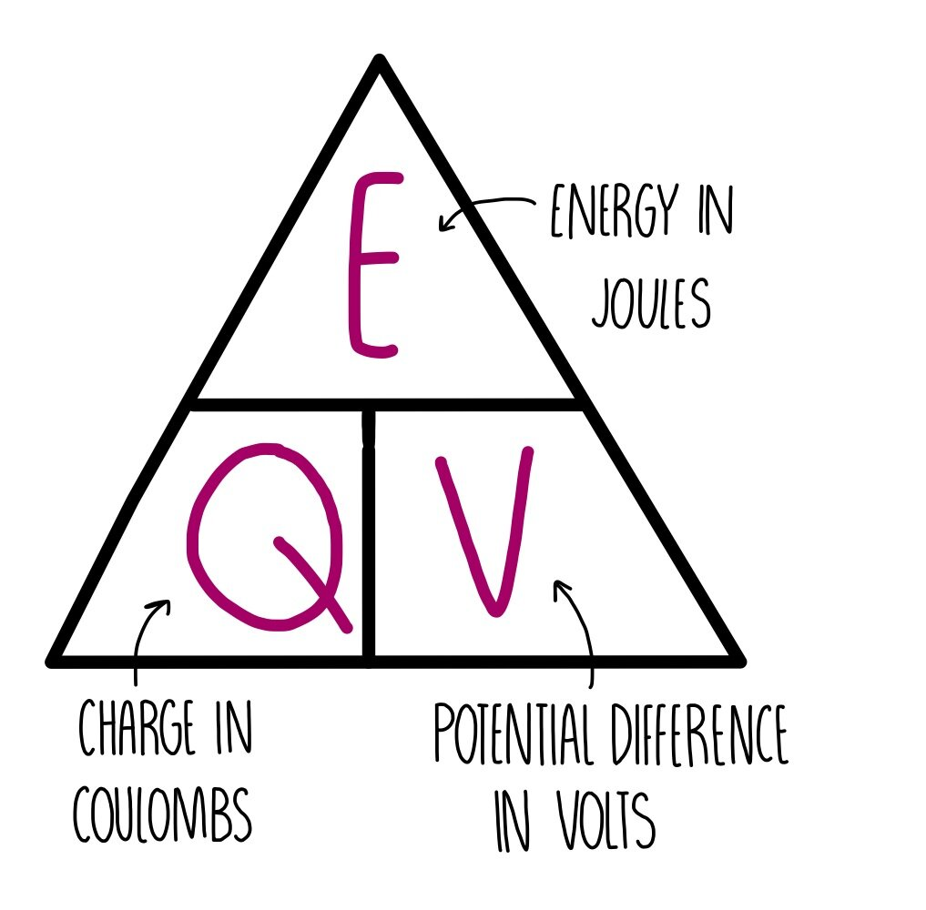
Voltage Calculations
- Voltage is measured in volts (V).
- The voltage of a battery is the amount of Energy (J) carried by 1 Coulomb of electrons in a circuit.
$$V=\frac{E}{Q}$$ | V = voltage in Volts (V)  E = energy in Joules (J)  Q = charge in Coulombs (C)

Example 1)  A light bulb is powered by 3 AA batteries. How much energy is delivered to the bulb if 20 C of charge is used? | Example 2)  A car battery is 12 V and sends out 28 kJ of energy. How much electric charge does the battery hold?

Series and Parallel Combinations of Cells  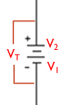  - When cells are connected in series, we can find the total amount of voltage by just adding them together.  - V_{T} = V₁ + V₂ + … | Example: Calculate the total voltage of this battery made of three, 2-volt cells connected in series. Draw the voltmeter set-up that could measure this total voltage change.
- When cells are combined in parallel, the voltage does not increase but the amount of charge (current) does.  - Advantages: greater current or longer battery life  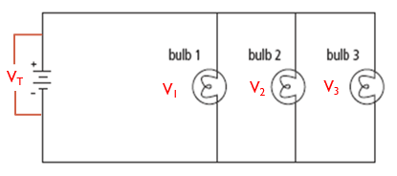  - V_{T} = V₁ = V₂ = V₃ | Example: Calculate the total voltage of this battery made of three, 2-volt cells connected in parallel. Draw the voltmeter set-up that could measure this total voltage change.
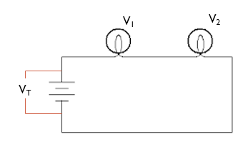
Loads Connected in Series
- Rule: The total voltage gained from the battery is equal to the total voltage drop from all the loads combined.
- V_{T} = _________________________

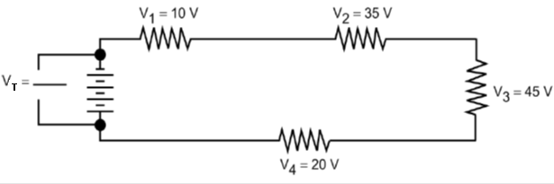
Example:

What is $V_{T}$?

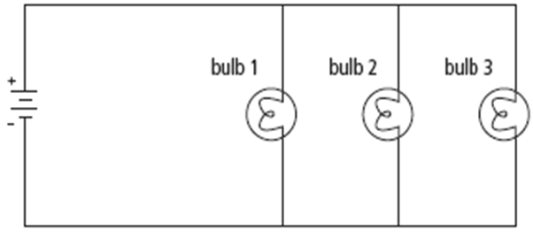
Loads Connected in Parallel
V₁
V₂
V₃
V_{T}
- When electrons go through devices in parallel, they split at junction points.
- Each load in parallel will receive the same amount of energy/Voltage.
- V_{T} = _______________________
Example: If V₁=10V, Calculate V_{T}, V₂ and V₃.
V₁
V₂
V₃
V_{T}

