Name: ________________________________________ Date: _________________________ Block: _______
1.5 – Immune System Notes (Science 8)
Immune System:
  - The body system that ____________________________________________________________
  - Has three ______________________________________ to protect us from pathogens
- The First Line of Defense: skin and linings of internal body systems
- _______________
  - Skin is a _____________________barrier to keep pathogens from entering body
  - ______________ and natural body acids: kill pathogens on skin ____________________
- Linings of the ___________________________ system
  - _____________ in your nose and throat: ____________ pathogens and move them back out of your body
  - __________________: pathogens get caught in sticky mucus and are removed from your body when you _________________, __________________, and _____________________
- Contents and linings of the ___________________________ system
  - Strong ____________ in your __________________: kill many types of pathogens
  - Mucus: _____________ pathogens that are then removed by __________________
- The Second Line of Defense: white blood cells and inflammation
- White Blood Cells (____________)
  - _______________________________ pathogens that get through the __________ line of defence
  - Some WBCs release ____________________ that make it easier for other WBCs to kill pathogens
- Inflammation
  - A process that causes a part of the body to become ______________________________
  - Occurs if you have an ___________________ or ________________________
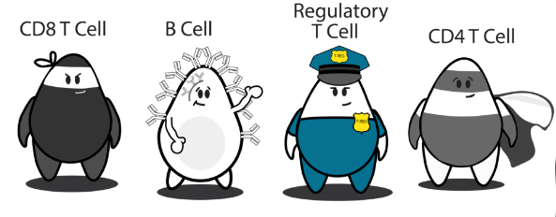
  - Increased blood flow _____________________________ move into the affected area and __________________________________
- The Third Line of Defence: specialized white blood cells
- Specialized white blood cells (e.g. T cells, B cells)
  - Recognize pathogens that they have previously fought
  - If the same pathogen enters the body in the future, they ___________________________ so you don’t get sick again
- T cells: ________________________________________________________________________
B cells: ________________________________
(Antibodies are particles in the bloodstream that _______________________________ produced by _____________________________________________. Antibodies _______________ to and _______________________ pathogens and infected cells.

Practice:
In your own words, describe the role of the immune system.
_____________________________________________________________________________________
_____________________________________________________________________________________

Why does the immune system need multiple lines of defense?
_____________________________________________________________________________________
_____________________________________________________________________________________
_____________________________________________________________________________________

Classify each of the following statements as describing the first, second, or third lines of defense.
- Mucus can trap pathogens. ______
- Specialized white blood cells, called T cells and B cells, allow your body to develop an immune response that prevents further infection. ______
- The skin and the linings of internal body systems stop many pathogens. ______
- Inflammation causes a part of the body to become red and swollen as blood cells move into the area. ______
- Acids given off by the body can kill some pathogens. ______
- White blood cells can surround and kill pathogens keeping infection from spreading. ______
- The immune system defends against pathogens and infection. ______

In your castle analogy, how did you represent each of the three lines of defense? Explain your analogy in your own words. If there were any aspects of the immune system that you were unable to represent in your analogy, describe them as well.
_____________________________________________________________________________________
_____________________________________________________________________________________
_____________________________________________________________________________________
_____________________________________________________________________________________
_____________________________________________________________________________________
_____________________________________________________________________________________
_____________________________________________________________________________________
_____________________________________________________________________________________
_____________________________________________________________________________________
_____________________________________________________________________________________
_____________________________________________________________________________________
_____________________________________________________________________________________

