Name: ___________________________________ Date: ___________________ Period: ________
Science 8 Notes Package (2.3.3 Changes of State)
A change of state is when matter transforms from one state to another. Examples:
- Liquid water becoming solid water (ice)
- Solid gold becoming liquid gold

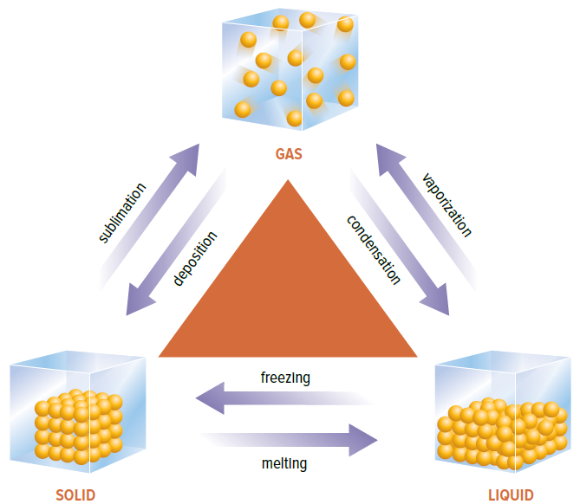
Complete the diagram below using the word bank. Use colour to show increases and decreases in energy.
Word Bank:
Sublimation; Deposition; Vaporization; Condensation; Freezing; Melting; Gas; Solid; Liquid

Temperature is a measure of the average _______________________________ of particles in a substance.
- Kinetic energy: ________________________________ ________________________________
- If you add kinetic energy to matter, its temperature will ______________________.
- If you remove kinetic energy from matter, its temperature will _______________________.
Change of state:
- Warming: heat energy converted to kinetic energy and makes particles move faster.
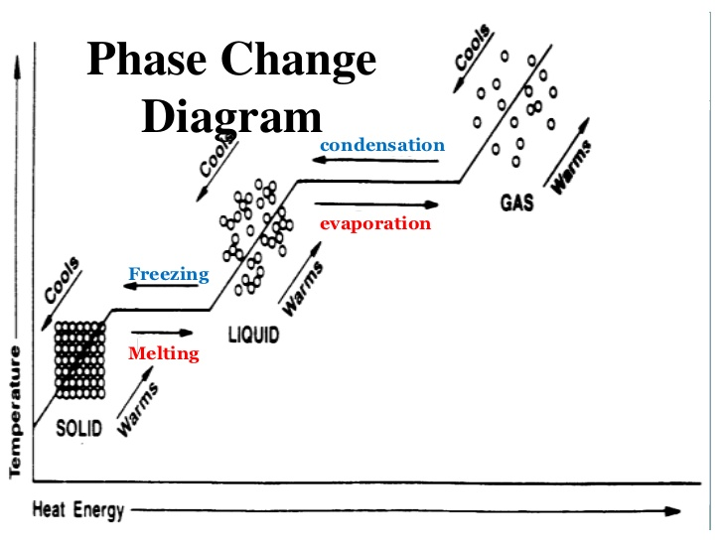
- Phase change: heat energy used to overcome attraction forces between particles

Science 8 Notes Package (2.3.4 The Kinetic Molecular Theory Explains Physical Changes and Properties)
What is dissolving (e.g. when sugar dissolves in water and ‘disappears’)?

What is diffusion?

Solids, liquids, and gases _________________ when heated, and _________________ when cooled.
Thermal expansion: the ________________________________________________________.

Practice Questions:
Use the KMT to explain why a balloon in a hot car will expand and may eventually pop.

Use the KMT to explain what happens when salt dissolves in water.

