Behaviour of Light at Surfaces Name: _____________________________ Date: ___________
- Write down definitions in your own words for:
Transparent: ___________________________________________________________________________
Translucent: ___________________________________________________________________________
Opaque: ___________________________________________________________________________
- Look around the room and classify as many objects as you can find into the following categories. You can continue this table on the back of this page.
Transparent | Translucent | Opaque

- Complete the following ray diagrams by showing what happens to the light as it hits each surface.
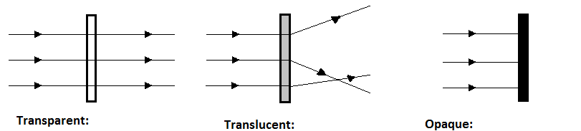
- Some jellyfish are transparent. How might this affect their ability to survive?

- Why is frosted glass often used for bathroom windows instead of clear glass or a solid wall?

Homework: PICK ONE.
- Choose two materials from your daily life and take photos of them to bring to class. For each material, answer these q’s:
  - Is the material transparent, translucent, or opaque? How could you confirm your decisions?
  - Explain how the material’s interaction with light is related to its function.
- Research a living organism (not jellyfish) that uses one of today’s concepts to help it survive or be better suited to its environment. Bring a photo and the results of your investigation to class and be prepared to share.

