Algae (Chapter 20)

Part 1: Characteristics of Algae
Key Characteristics
- Photosynthetic, have ______________________ (and sometimes other photosynthetic pigments)
- Eukaryotic
- ________________________ or ________________________
- Aquatic
- Classification debated; no clear definition on what ‘algae’ are

Adaptations for Aquatic Living
- Thin leaf-like structures; exchange gases and nutrients directly with surroundings
- No ______________________________________ to transport water
- No _________________________________ (water provides sufficient support)
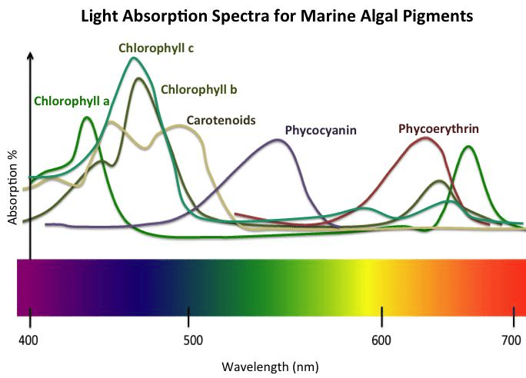
Chlorophyll and Accessory Pigments
- All algae have chlorophyll a, which uses red and violet light (scarce underwater)
- Algae often use different forms of chlorophyll (b, c, d) and/or ____________________________ _________________ to use other wavelengths of light

- Why do leaves appear green to our eyes?

- The leaves of trees have chlorophyll and carotenoids. In the fall, green leaves break down and recycle their chlorophyll, leaving the carotenoids behind. Why does this cause the leaves to change colour to yellow, orange, and red?

- Water filters out long-wave visible light like red, orange, and yellow. Some algae live on the sea floor.
  - What pigments are these algae likely to utilize? _________________________________
  - What colour are these algae likely to be? ______________________________________

Part 2: Groups of Algae
Chlorophyta (Green Algae)
- Have ______________________________
- Colour: ___________
- Store food as starch
- Habitat: ____________________________________________
- Solitary or colonial
Some green algae are colonial. What is a colony? What are three examples of colonial green algae?

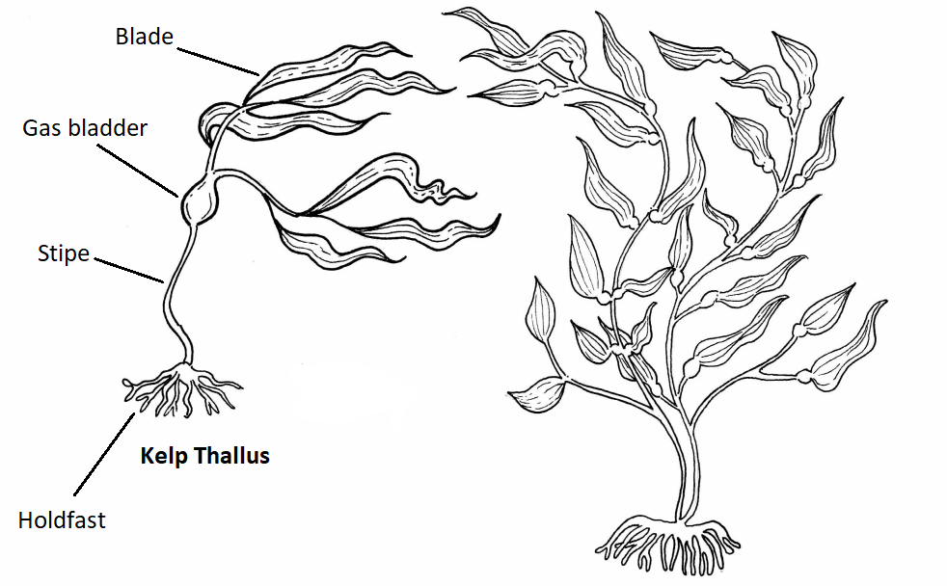
Label this diagram of kelp, a brown alga.
Phaeophyta (Brown Algae)
- “Seaweeds”
- Chlorophylls ____ and _____, accessory pigment ____________________________
- Colour: _____________
- Store food as starch and oil
- Habitat: ___________________________________
________________________________, arctic areas
- Can grow to very large in size (__________________),
with complex structures
Brown Algae: Fucus Anatomy
- Blade: used for ________________________
- Gas bladder: filled with gas for _______________
- Holdfast: ________________ algae down to rock or other substrate

Rhodophyta (Red Algae)
- Chlorophyll _________________________, accessory pigment ____________________(absorbs _______________ light)
- Colours: __________________________________
- Live at greater depths than other algae (up to ______________________)
- Store food as starch
- E.g. Porphyra (__________________________________)

Part 3: Where Algae Fit into the World
- Why are algae important for the world and other living things overall?

- Why are algae important to humans?

