Name: _________________________________ Date: _____________________ Period: _______
Acids and Bases (All About That Base)
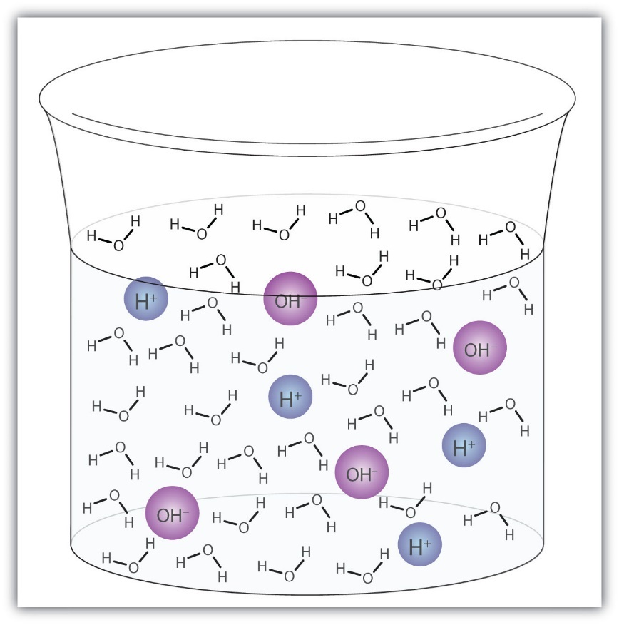https://saylordotorg.github.io/text_the-basics-of-general-organic-and-biological-chemistry/s13-03-water-both-an-acid-and-a-base.html
Ions and Water
Water naturally dissociates (breaks apart) into its ions according to the formula:
In any aqueous (water-based) solution, there will be some hydrogen (H⁺) ions and some hydroxide (OH⁻) ions, alongside the actual water molecules.
A neutral solution is one where the concentration of H⁺ and OH⁻ ions is equal. For every H⁺ ion, there will be one OH⁻ ion.

pH Scale
Molarity
M or Molarity is a derived unit representing moles/Liters. (A mole represents a very large number of particles.)
M is a unit of concentration. The higher the Molarity, the higher the concentration, and the more particles there are in that space. The lower the Molarity, the lower the concentration, and the fewer particles there are in that space.
pH is used to determine the relative concentration of H⁺ and OH⁻ ions in solution. It is a logarithmic scale.
In a neutral solution with a pH of 7, the amount of H⁺ and OH⁻ ions is equal. The concentration of H⁺ ions is 10⁻⁷ M, and the concentration of OH⁻ ions is 10⁻⁷ M.

Acids and Bases
Acids are ionic compounds containing the H⁺ cation. When dissolved, the ions dissociate (separate), so that the concentration of H⁺ ions increases and the concentration of OH⁻ ions decreases.  Properties of acids:  - pH less than 7  - Taste sour (often in drinks!)  - Burn skin  - React with metals  - Conduct electricity  Examples of acids: | Bases are ionic compounds containing the OH⁻ anion. When dissolved, the ions dissociate so that the concentration of OH⁻ ions increases and the concentration of H⁺ ions decreases.  Properties of bases:  - pH greater than 7  - Taste bitter  - Burn skin  - May feel slippery  - Conduct electricity  Examples of bases:
How to tell acids and bases apart from their formulas:
____________________________________________________________________________________
Draw the ions in an acid (e.g. pH 6) | Draw the ions in a base (e.g. pH 8)
Draw the ions in a strong acid (e.g. pH 2) | Draw the ions in a strong base (e.g. pH 13)
The stronger the acid, the __________________ the pH, and the greater the concentration of ______ compared to ______. | The stronger the base, the __________________ the pH, and the greater the concentration of ______ compared to ______.

pH and Concentration Calculations
pH | Identity | Concentration of H⁺ (M) | Concentration of OH⁻ (M)
1 | Acid | 10⁻¹ | 10⁻¹³
3 | Acid | 10⁻³ | 10⁻¹¹
5 | Acid | 10⁻⁵ | 10⁻⁹
7 | Neutral | 10⁻⁷ | 10⁻⁷
9 | Base | 10⁻⁹ | 10⁻⁵
11 | Base | 10⁻¹¹ | 10⁻³
13 | Base | 10⁻¹³ | 10⁻¹
pH can be used to calculate ion concentration and vice versa. Examine the above table and use it to answer the following questions. (Reminder: 10⁻¹ = 0.1; 10⁻² = 0.01; 10⁻³ = 0.001; etc.)
- How can you use pH to determine whether something is acidic, neutral or basic?

- How do you use ion concentration to determine whether something is acidic, neutral, or basic?

- How do you use pH to find the concentration of H⁺ ions in solution?

- How do you use pH to find the concentration of OH⁻ ions in solution?

Comparing Solutions Using pH and Ion Concentrations
You may be asked to compare two different solutions.
Use the following formula:
$$Difference in Strength or Concentration= {10}^{pH difference}$$
Tips:
- When calculating pH difference, make sure to subtract the smaller pH from the larger one.
- When drawing your conclusion, remember: lower pH = more acidic (less basic); higher pH = more basic (less acidic).

Example: How many times more acidic is lemon juice than tomatoes?
$$Difference in Strength= {10}^{pH difference}={10}^{4-2}={10}^{2}=100$$
Conclusions:
- Lemon juice is 100x more acidic than tomatoes.
- Tomatoes is 100x more basic than tomatoes.
- Lemon juice has a 100x greater concentration of H⁺ ions than tomatoes.
- Tomatoes has a 100x greater concentration of OH⁻ ions than lemons.

Example: Chicken soup has a pH of 5.80. Orange juice has a pH of 3.50. Which is more acidic? By how many times?
$$Difference in Strength= {10}^{pH difference}={10}^{5.80-3.50}={10}^{2.30}=200$$
Conclusions:
- Orange juice is 200x more acidic than chicken soup.
- Chicken soup is 200x more basic than orange juice.
- Orange juice has a 200x greater concentration of H⁺ ions than chicken soup.
- Chicken soup has a 200x greater concentration of OH⁻ ions than orange juice.

- Compare the following solutions. For each, state:
i) Which is more acidic or basic?
ii) How many times more acidic or basic?
- Soap and eggs

- Oven cleaner and baking soda

- Vinegar (pH 2.9) and milk

- Seawater (pH 7.7) and human blood (pH 7.3)

Acid-Base Indicators
Indicators are used to determine the approximate pH of a substance. There are many different kinds of indicators.
- What colour will each of the indicators be in a solution with the following pHs?
 | 2 | 4 | 6.5 | 9 | 12
Methyl orange
Phenolphthalein
Litmus
Bromothymol blue
Indigo carmine

- What colour will phenolphthalein be in a solution with a OH⁻ concentration of 10⁻⁴ M?

Lab 5-1B (Green Science 10 Textbook)
Observations
 | Magnesium ribbon | Red litmus | Blue litmus | Bromothymol blue | Indigo carmine | Methyl orange
A
B
C
D

Questions (answer on separate sheet of paper)
- List the solutions in order from most acidic to least acidic (most basic).
- Which solution do you think was neutral? Explain how you know.
- You used two bases. Explain how you know which solution was more alkaline (more basic).

  - What colour would each of the five indicators be in a solution that is pH 3?
  - What colour would each of the five indicators be in a solution that is pH 10?

