Amoeba Sisters Video Recap – DNA, Chromosomes, Genes, and Traits: An Intro to Heredity
- Explain what this image represents regarding where your entire DNA code can be found.
______________________________________________________________________
______________________________________________________________________
______________________________________________________________________
- One of these images represents sexual reproduction, and the other represents asexual reproduction. Label them and then briefly describe what each means in your own words. | 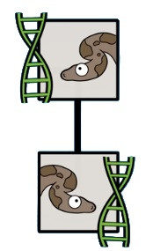_______________ | Explain:  __________________  __________________  __________________  __________________  __________________ | 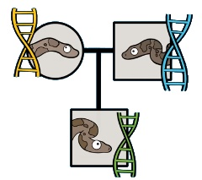_________________ | Explain:  __________________  __________________  __________________  __________________  __________________
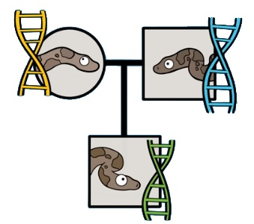
- Spike is not a clone of his father. He inherited DNA from both of his parents. Chromosomes are condensed units of DNA. If Spike has 36 chromosomes, you would expect that Spike would have inherited _____ chromosomes from his mother and _____ chromosomes from his father.

- How did you determine the chromosome numbers?
______________________________________________________________________________
______________________________________________________________________________
- Label the diagram on the right using the following words:
(A) Sugar, (B) Phosphate, (C) Nitrogenous Base

- What is a nucleotide?
_____________________________________________________

How many nucleotides do you see in this diagram? ______

- What are the four different types of bases in DNA and how
do they pair?
_____________________________________________________
_____________________________________________________

- In your own words, what is the relationship of DNA bases
and traits such as hair colour, eye colour, etc?
_________________________________________________________________________________________________________
_________________________________________________________________________________________________________

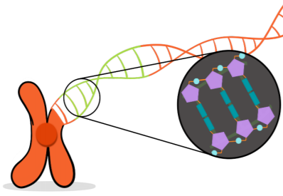
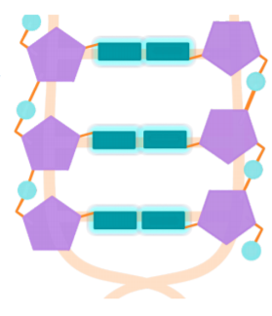
- Label the illustration with the following words:

DNA
Double Helix*
Nucleotide
Phosphate
Sugar
Nitrogenous Base
Chromosome
Centromere*

* Not directly covered in video. Ask your teacher!

