Name: ______________________ Date: __________________ Block: _______
Natural Selection Worksheet Package

Case Study A: A Prickly Situation
Below is a series of pictures representing changes in a population of cacti. Pictures 1 and 2 show what happened when a deer came to eat, picture 3 shows the cacti a few weeks later (notice the flowers on the right-hand cactus), and picture 4 shows the situation a few months later.

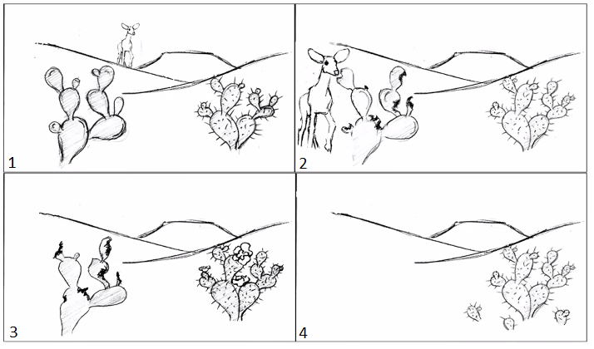
- What is overproduction?

- Genetic Variation within the population: In picture 1, what is the main difference between the cactus on the left and the cactus on the right?

- Selection: Why would a deer be more likely to eat the cactus on the left than the cactus on the right in picture 1? What effect does the deer's behaviour have on the survival and reproduction of these two types of cactus?

- Adaptation/Evolution: Do you think that evolution by natural selection is occurring in this cactus population? (Assume there is actually a large population of cacti, with some that look like each type of cactus shown above.) Explain why or why not.

Case Study B: Peppered Moths
Background:
Peppered moths have lived in the forests around Manchester, England for hundreds of years. There are two genetic variations for colour in peppered moths: the moths can be dark with light spots OR light with dark spots. Various birds eat both kinds of moths if they can spot them.
Before the 1800s (figure 14.11a), the trees were light-coloured and the light-coloured moths were camouflaged. After the 1800s, when England went through the Industrial Revolution, the pollution from factories made the trees darken (figure 14.11b). Now, the trees were dark-coloured and the dark-coloured moths were camouflaged.

Data:
The table below displays the number of peppered moths of each colour found over a 10-year period. Graph the data below to show how the peppered moth populations changed in the 1800s. You should make a line graph with two lines. Years should be on the x-axis and number of moths on the y-axis. Assume “Year 1” was the start of the Industrial Revolution. Don’t forget a legend.

Peppered Moth Populations
Year | Light Coloured Population | Dark Coloured Population
1 | 537 | 112
2 | 484 | 198
3 | 392 | 210
4 | 246 | 281
5 | 225 | 357
6 | 193 | 412
7 | 147 | 503
8 | 84 | 594
9 | 53 | 638
10 | 38 | 673

Line Graph:

Analysis Questions:
- What changes occurred in both forms of the moth over these ten years?

- Why do you think these changes occurred? (Discuss all 4 elements of natural selection in your answer in relation to the case study.)

- England has recently cleaned up their factories and now produces much less pollution. As a result, the trees are slowly becoming lighter in colour. What might happen to the populations of each form of the moth in the next 10 years? Why?

Case Study C: Rock Pocket Mouse

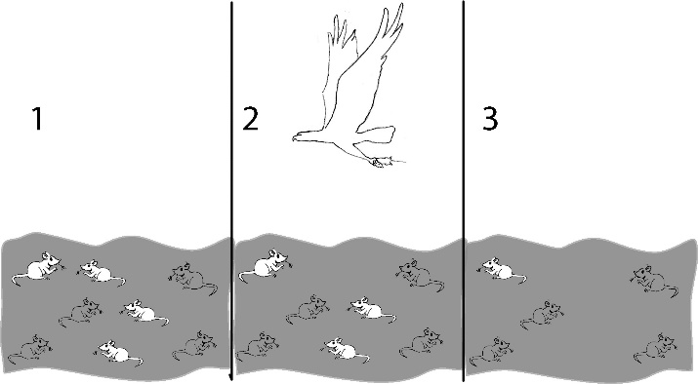
- Describe what is happening in figures 1-3 to the right. Is the population of mice different in figure 3 than in figure 1? Explain why.

Living things that are well adapted to their environment survive and reproduce. Those that are not well adapted don’t survive and reproduce (or reproduce less). An adaptation is any characteristic that increases fitness, which is defined as the ability to survive and reproduce.

- What characteristic of the mice is an adaptation that increased their fitness in #3?

- The table below gives descriptions of four female mice that live in a beach area which is mostly tan sand with scattered plants. Which mouse would biologists consider the fittest? Explain why.

Colour of fur | Black | Tan | Tan and Black | Cream
Age at death | 2 months | 8 months | 4 months | 2 months
# pups produced by each female | 0 | 11 | 3 | 0
Running speed | 8 cm/sec | 6 cm/sec | 7 cm/sec | 5 cm/sec

- A more complete definition of fitness is the ability to survive and produce offspring who can also survive and reproduce. Below are descriptions of four male lions. According to this definition of fitness, which lion would biologists consider the “fittest”? Explain why.

Name | George | Dwayne | Spot | Tyrone
Age at death | 13 years | 16 years | 12 years | 10 years
# cubs fathered | 19 | 25 | 20 | 20
# cubs surviving to adulthood | 15 | 14 | 14 | 19
Size | 10 feet | 8.5 feet | 9 feet | - feet

Summary + Extension Questions

Suppose that Tyrone had genes that he passed on to his cubs that helped his cubs to resist infections, so they were more likely to survive to adulthood. These genes would be more common in the next generation, since more of the cubs with these genes would survive to reproduce.
A characteristic which is influenced by genes and passed from parents to offspring is called heritable. Over many generations heritable adaptive characteristics become more common in a population. This process is called evolution by natural selection. Evolution by natural selection takes place over many, many generations.
Evolution by natural selection leads to adaptation within a population. The term evolution by natural selection does not refer to individuals changing, only to changes in the frequency of adaptive characteristics in the population as a whole. For example, for the mice that lived in the beach area with tan sand, none of the mice had a change in the colour of their fur; however, due to natural selection, tan fur was more common for the pups than for the mother mice.
In summary, a heritable characteristic that helps an organism to have more offspring which survive to reproduce will tend to become more common in a population as a result of evolution by natural selection.

- Explain why a characteristic which helps an animal to live longer will generally tend to become more common in the population as a result of evolution by natural selection.

- Not all heritable characteristics which contribute to longer life become more common in the population. Some characteristics contribute to long life, but not more offspring. For example, a female cat which is sterile and cannot have any offspring may live longer because she will not experience the biological stresses of repeated pregnancies. Explain why a characteristic like this which contributes to a long life, but with few or no offspring, would not become more common as a result of evolution by natural selection.

