Feb 2, 2018,05:10pm EST; Note: original article has been edited slightly to simplify concepts.

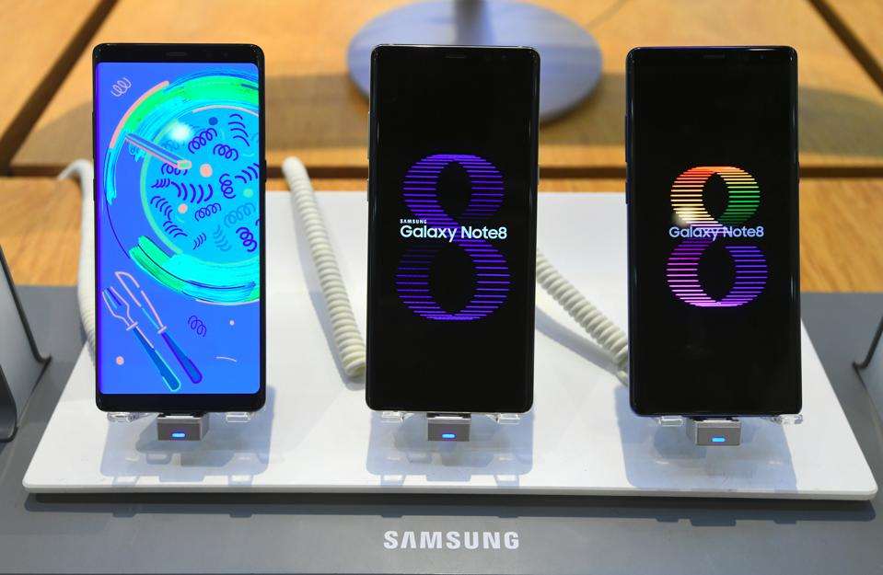
The Truth About Cell Phone Radiation

(JUNG YEON-JE/AFP/Getty Images)
The word ‘radiation’ sounds scary, but in reality it includes any type of electromagnetic wave (and some particles too, but let's not get into that here)—gamma rays, x-rays, ultraviolet light, visible light, infrared light, terahertz, gigahertz, megahertz, microwave, and radio waves (see: Electromagnetic spectrum).
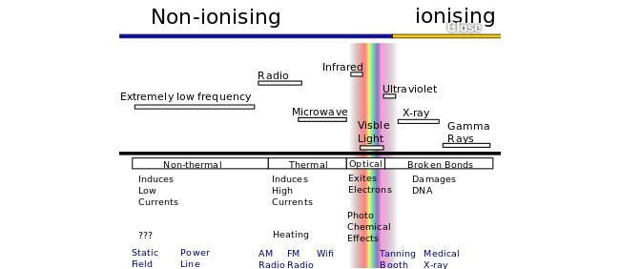
The electromagnetic spectrum is broken up into two parts based on whether small doses of that radiation can cause harm: ionizing radiation and non-ionizing radiation. Ionizing radiation—UV, x-rays, and gamma rays—has enough energy in one photon (a ‘particle’ of light) to remove electrons from atoms or break apart chemical bonds. It is because of this potential for cancer-causing DNA damage that you wear a lead vest when you get x-rays at the dentist and you are advised to wear sunblock when you go out in the sun. One can’t avoid natural (radon, cosmic rays when you are up in an airplane) and man made (diagnostic x-rays) sources of ionizing radiation completely, but it is reasonable advice to minimize exposure when possible.

Electromagnetic spectrum divided into ionizing and non-ionizing radiation. Source: Non-ionizing radiation.
Then there is non-ionizing radiation, which encompasses the vast majority of light we are exposed to: visible light from lightbulbs, infrared light from an oven and from people, gigahertz light from our wifi, megahertz light to/from our cell phones, and radio waves hitting our car radio. They are not harmful in small doses because one photon does not have enough energy to ionize atoms and/or break apart molecules. In very large doses, non-ionizing radiation can be harmful. For example, a visible light laser with sufficient power (at least several hundred times more than a legal laser pointer) which is concentrated in a small enough spot will burn your skin and do worse things to your eye if it gets in there. And those of us who are old enough, remember the gerbil-in-a-microwave flash animations which went viral 17 years ago [1] as a humorous (but not exactly factual) representation of what would happen if you microwaved a live rodent.
To assess whether cell phone radiation is harmful, we need to know:
- What frequency do they emit/receive and what is the power of this radiation?
- How does this frequency interact with matter?
- Is cell phone radiation enough to cause damage to humans, given its frequency, power, and interaction mechanism?
The first one is easy, cellular frequencies vary between 450–2000MHz, but 800 or 900 MHz is the most common. The power emitted by a cell phone varies over the course of the call (higher when making initial contact, which lasts a few seconds). It can go up to 2 Watts at the start of a call, and can go down to .02 Watts during optimal operation [2]. Of course, most people barely use cell phones for calls, but I am using this example as a worst case scenario, because the phone is not right by your head when you are browsing Tinder.
In this frequency range, the interaction between matter and light would result in heat [3]. This is the same technique employed by microwave ovens (which operate at 2450 MHz [4]). So if cell phones were to cause damage to tissue, the mechanism would be the same as what happens in a microwave oven—boiling the water in your head/body.
It should be noted that microwave ovens emit 700 Watts of power, hundreds of times more than the maximum that a cell phone does (and thousands of times more than your cell phone does during the majority of your call).
Another way to think about the situation is to consider a cell phone emitting .02 Watts constantly and ask how long it would take to heat up your body if your entire body was exposed the radiation. Assuming your body mass is 100 kg and is composed entirely of water, calculations show that it would take 241 days for the cell phone radiation to heat you up by one degree. Fortunately, you have metabolic processes in your body, or possibly air conditioning, to mitigate this heating.
Therefore, the recent study [5] about cell phones causing cancer in rats should be taken with a grain of salt when making the connection to humans [6]. In particular, the rats in the study were exposed to radiation power densities of 0, 1.5, 3, or 6 W/kg (see p 7 in ref. 4 below). This would be equivalent of the 100 kg human getting up to 600 Watts — basically getting microwaved. As discussed earlier, cell phones are hundreds of times weaker.
Footnotes
[1] Gerbil in a Microwave
[2] Anatomy of a GSM mobile phone signal
[3] Water and microwaves
[4] Microwave oven
[5] http://biorxiv.org/content/biorx...
[6] Questions and Answers on the New Study Linking Cellphones and Cancer in Rats
This question originally appeared on Quora - the place to gain and share knowledge, empowering people to learn from others and better understand the world. You can follow Quora on Twitter, Facebook, and Google+. More questions:

