Compound Microscope: Parts and Functions Name: ______________________________
# | Name | Function
1
2 |  | ______________________________________________ and ___________________ them into place.
3 |  | Primary _____________________ source (ranges from ____x- _____x magnification).  LOW: _______ MED: _______ HIGH: _______
4 |  | Holds the microscope _______________ in place
5 |  | Controls amount of ________________________
6 |  | Illuminates the slide
7 |  | _____________________________________ - usually has ______x magnification
8 |  | Support the body tube; used to carry the microscope
9 |  | Where _______________________________________; can be moved up/down using adjustment knobs
10 |  | ___________________________ the microscope;  Only to be used with ____________ and ________________ power objective lenses
11 |  | ___________________ the microscope;  Used with _____________-power objective lenses
12 |  | Supports the microscope; used to carry the microscope

Date: _______________________________
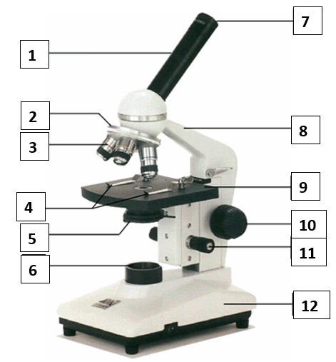

On the back of this page, answer the following questions:
- How should you pick up a microscope?

- How should you put away a microscope? (LOSE-C)

