Practice Test Questions: Science 9 Current Electricity
Here are practice questions to help you prepare for the upcoming test. Recommended target times for each question are in brackets.

Current Calculations (more on worksheet)
- Convert the following (1 minute each)
  - 28 mA to A
  - 9 V to mV
  - 189 A to mA
  - 15.3 mA to A
- Calculate the current in a circuit where 24 C of charge passes by in 10s. (2 minutes)
- Calculate how much charge passes through a lightbulb in 5 minutes if the current through the lightbulb is 100 mA. (3 minutes)

Circuit Diagrams
- A circuit requires three key components: a source, load, and wire. Define these terms in your own words and give examples of each. (5 minutes)
- (5 minutes)
  - Draw a circuit diagram with: one 9V battery in series with a fan and an open switch.
  - Label the positive and negative terminals of the battery.
  - Draw arrows to indicate the path and direction of electric current in this circuit.
  - The resistance of the fan is 110 Ω. Calculate the current in this circuit.
- (5 minutes)
- Draw a circuit diagram with: three 1.5V cells and a lightbulb in series, and two lightbulbs in parallel.
- Add a single switch that will control all the lightbulbs in the circuit (i.e. will turn all of them on, or all of them off).
- Add a voltmeter that will measure the voltage across the lightbulb that is in series.
- Draw arrows to indicate the path and direction of electric current in this circuit.
- (10 minutes)
  - Draw a circuit diagram with: two 3V cells in parallel, and a lightbulb, an ammeter, and a resistor in series.
  - Draw arrows to indicate the path and direction of electric current in this circuit.
  - What is the total voltage gain of the circuit?
  - If the voltage drop across the resistor is 1V, what is the voltage drop across the lightbulb?
  - The ammeter measures a current of 5A. What is the total resistance of the circuit?
  - How much charge flows through a single 3V cell in the circuit in ten minutes?
- (10 minutes)
- Draw a circuit diagram with: a battery made of three 1.5V cells in series, and three identical 10Ω lightbulbs in parallel.
- Label the negative and positive terminals of the battery.
- Draw arrows to indicate the path and direction of electric current in this circuit.
- The current leaving the negative terminal of the battery is 80 mA. Calculate the current that goes through each of the lightbulbs.
- What is the voltage drop across each of the lightbulbs?
- (5-10 minutes depending on depth/length of answers)
- Draw a circuit diagram with: a battery made of two 1.5V cells, and a wire connecting the negative and positive terminals of the battery.
- This is called a short circuit. Explain briefly what this circuit is missing.
- If the short circuit is allowed to persist, the wire and the battery will both become extremely hot and be a fire hazard. Explain why this is. (Hint: look at the first page of your Notes #4 on Resistance).
- Suppose that you measured the current in your short circuit. Would you expect the current to be high, normal, or low? Explain briefly.

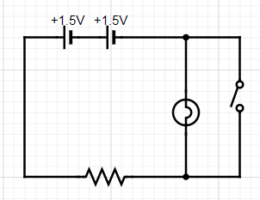
Circuit Analysis
- (3-5 minutes depending on depth/length of answers)
- Draw arrows to indicate the path and direction of electric current in this circuit. (Hint: will any current go through the open switch?)
- Do you expect the lightbulb to be on or off in this circuit? What will happen to the lightbulb when the switch is closed? Explain briefly in terms of electric current.
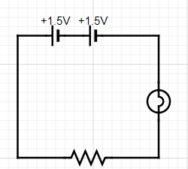
- (7 minutes)
- What is the total voltage of the battery?
- Draw a voltmeter that will measure the total voltage of the battery.
- Suppose the voltage drop across the lightbulb is 1.2V. What will the voltage drop across the resistor be?
- The total resistance of the circuit is 25 Ω. Calculate the current that is flowing across the resistor.
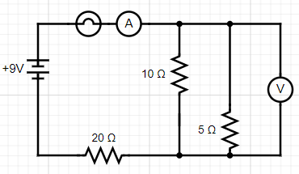
- (5-7 minutes depending on depth/length of answers)
- What voltage will the voltmeter read: greater than 9V, equal to 9V, or less than 9V? Explain briefly.
- Suppose the ammeter measures a current of 12A. If 4A is going through the 10Ω resistor, how much current is going through the 5Ω resistor? the 20Ω resistor?

Ohm’s Law (more on worksheet)
- A power saw at the local hardware store boasts of having a 16.7-Amp motor. Determine its resistance when plugged into a 110-Volt outlet. (2 minutes)
- A coffee cup immersion heater utilizes a heating coil with a resistance of 9.09 Ω. Determine the current through the coil when operated at 110 Volts. (2 minutes)
- A typical color television draws about 3810 mA and has a resistance of 30Ω. Determine the voltage of the source. (3 minutes)
- Suppose a circuit has an electric motor that is powered by a 9V battery. 150 Coulombs of charge passes through the electric motor every 10 seconds. Calculate the resistance of the motor. (4 minutes)

Miscellaneous
- Do you think the appliances in your home are connected in series or in parallel? Explain with evidence.

