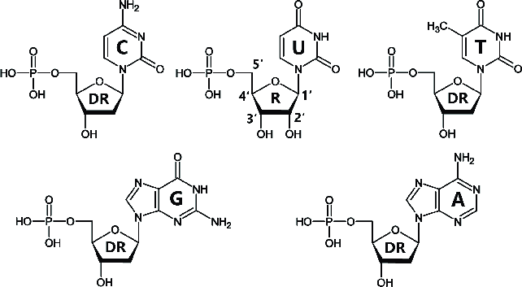
Figure 1. Molecular structure of nucleotides, showing phosphates and sugars. (DR=deoxyribose; R=ribose. Ribose and deoxyribose are different forms of 5-carbon sugars). At each ‘bend’ in the chemical structure without anything labelled, there is a carbon atom (see Figure 2). Source: http://a.2002-acura-tl-radio.info/page-a/diagram-of-nucleotide-gene-78006.html

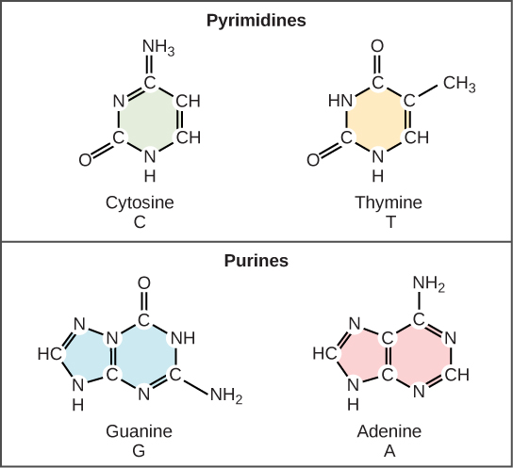  Figure 2. Complete chemical structure (including carbon atoms) of nitrogenous bases only (phosphates and sugars absent). Source: https://opentextbc.ca/conceptsofbiology1stcanadianedition/chapter/9-1-the-structure-of-dna/ | 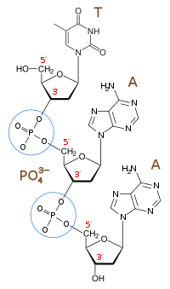  Figure 3. Successive nucleotides are linked by phosphodiester bonds, where the phosphate’s oxygen atoms bond covalently with carbon atoms on the 5-carbon sugars. Source: https://en.wikipedia.org/wiki/  Phosphodiester_bond

