Name: __________________________________________ Date: _______________________
DNA Base Pairing Worksheet
When a cell copies a DNA molecule:
- DNA is unzipped.
- The complementary bases are added to each template strand.
- The 2 new strands are proofread for errors.
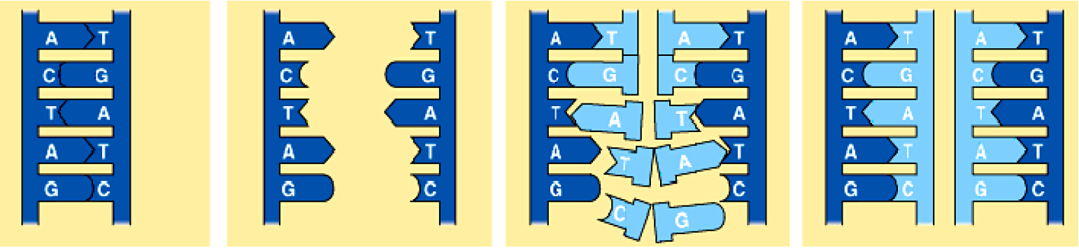
When a cell copies its DNA (replication), the original DNA ladder is broken apart and new nucleotides are added to the center. This creates two exact copies, each one made from half the original DNA molecule.
- DNA polymerase (the protein which builds DNA) will only attach bases which match with the original strand of DNA.
- In DNA replication, ____________________ and ____________________ will bond together and ____________________ and ____________________ will bond together. The bonds are called ____________________________________.
- When creating the matching strand the following pairing rules must be used:

Directions: Use the base pairing rules to figure out the sequence of the new strand of DNA for the original strands below. Write the complementary strand sequence directly underneath the original (template) strand.
- AACGTACGATCGATGCACATGCATGGCTACGC

- CCCGGGTATGCATGTACGTACGTCGTATATCG

- CGCGATCGAGCGATCGACGAATGCCTAGTTTT

- TTAAACGAGCTGCTAGCTATTTTTAAAACCCCG

- Why is DNA replication important?
____________________________________________________________________________________________________________________________________________________________
- What does a cell’s DNA contain the instructions for? (Sci10 Connections textbook pg 13)
____________________________________________________________________________________________________________________________________________________________

