Evolution by Natural Selection In-Class Activity
Instructions:
This handout has images representing natural selection. Please do not write on this page.
In a small group (2-3):
- Discuss how each image shows evolution by natural selection occurring, according to the three steps of natural selection (variation, survival and reproduction of the fittest, evolution).
- Assign each group member to one image. Individually, each person writes down a detailed, step-by-step description of how natural selection occurred in that population.
- Share and critique descriptions within your groups.
- Select one description from your group to revise and hand in. Write your names on it, as well as the title of the image.
*Note: none of the images are perfect. Some may show certain step(s) of natural selection better than others.

Image 1: Giraffe
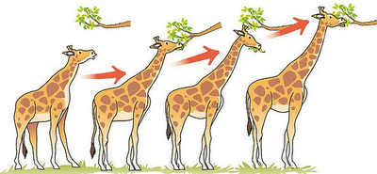

Image 2: Sea Urchin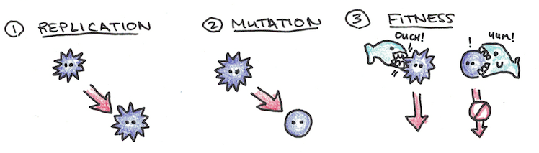

Image 3: Butterflies
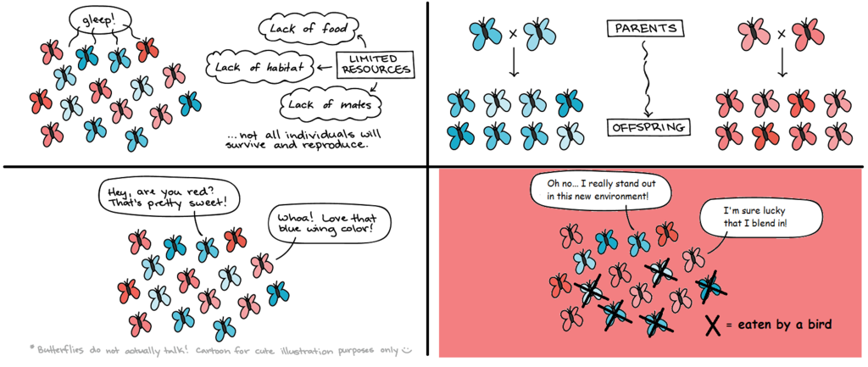

Image 4: Antibiotic Resistance
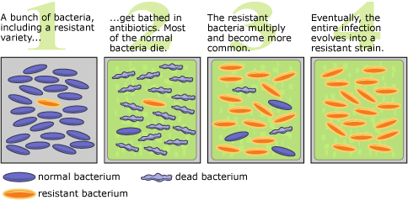

Extension Activity:
- Once we understand how evolution by natural selection works in the natural context, we can begin thinking about how non-living things undergo similar processes of evolution. Discuss and draw comic strips showing a modified version of the three steps of “evolution by natural selection” in one of the following:
  - Evolution of the restaurant scene in Vancouver
  - Evolution of culture (e.g. what causes some memes to persist or certain tiktok videos to become popular but not others?)

