Name: ______________________________________ Date: ____________________________ Block: ______
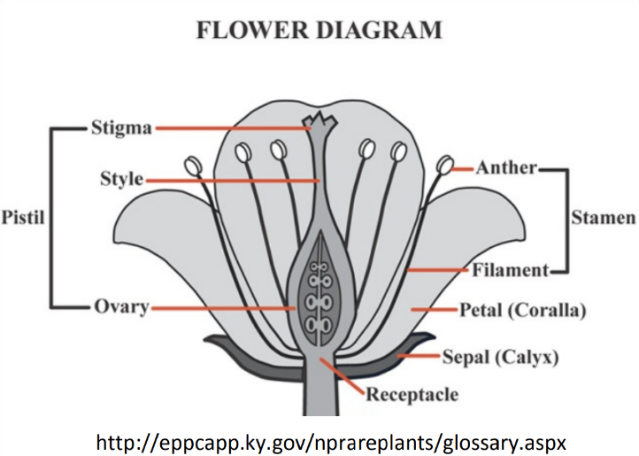
Flower Dissection Lab – Life Sciences 11
Background Information:
Flowers are the reproductive parts of many plants. Most flowers have both female and male parts. The female part of the plant is called the pistil. It is made of one or more carpels; each carpel contains the stigma, style, and ovary (which contains the eggs). The male part of a flower is called the stamen. It includes the anther and filament. The anther holds the pollen (sperm) of the plant.
- Is this angiosperm a monocot or a dicot? How do you know? Give two pieces of evidence: one from the flower, and one from a different part of the plant.

- Find and count the sepals at the base of your flower. Why is the sepal important to the development of the flower?

- Find and count the petals of your flower. Why are petals usually brightly colored?

- Find both parts of the stamen on your plant (the male part—anther and filament). Why is it important for the anthers to be towards the top of the flower?

- Based on your answer to #1, predict how many carpels you would expect to find in your flower. How many do you see? What do you notice about the carpels in this flower?

- Try your best to find all three parts of the pistil on your plant (stigma, style, and ovary). Cut open the ovary*. How many eggs are inside the ovary?
* Careful to draw the carpel on the next page before you cut anything open. You may tape a cross section of the ovary to the
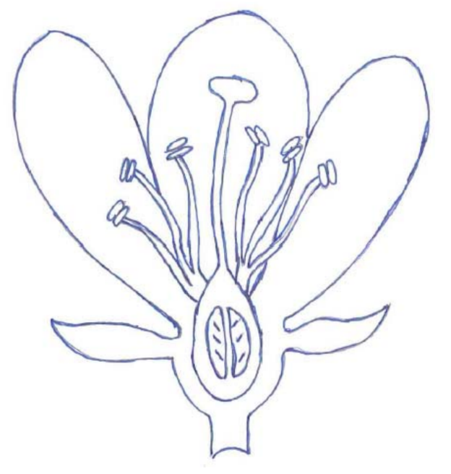
Materials: Flowers, Scissors, Magnifying Glass, Resource Materials (textbook, internet), Tape
Directions for Dissection: For each of the flower parts, record how many you found, and the function of each. Colour code the box and the diagram to match the flower part. Finally, cut and tape one example of each flower part to your sheet*.
*Note: for the carpel, this will not be possible for all members of your group. If so, do a rough sketch of the carpel instead.
- What is the common name and Latin name of the plant you have been assigned? (Reminder: proper formatting.)
Common name:
Latin name:
Sepal ☐ | How many? | Petal ☐ | How many?
Function: |  | Function:
Tape. |  | Tape.
Carpel ☐ | How many? | Stamen ☐ | How many?
Function: |  | Function:
Tape/draw and label stigma, style, ovary. |  | Tape and label filament, anther.

