Name: ___________________________________ Date: ________________________ Block: ________
Colour My Own Karyotype Activity
Step 1) Fill in the names of your grandparents (if known). Then, colour each grandparent’s chromosomes the colour that is indicated.
Name: _______________  Paternal Grandmother (dad’s mom) (YELLOW)  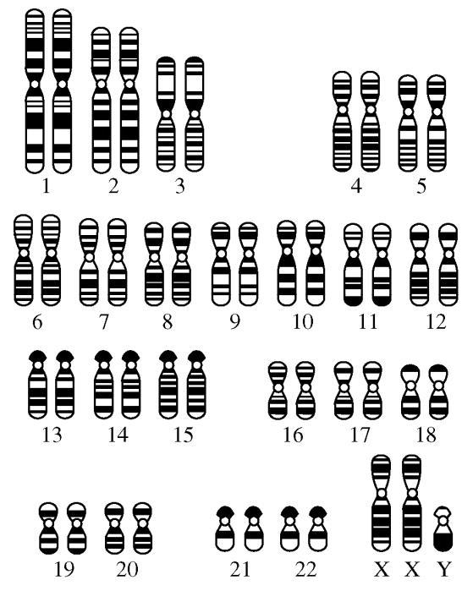 | Name: _______________  Paternal Grandfather (dad’s dad) (BLUE) | Name: _______________  Maternal Grandmother (mom’s mom) (PINK) | Name: _______________  Maternal Grandfather (mom’s dad) (GREEN)
Step 2) Your dad inherited 23 chromosomes from his mom and 23 chromosomes from his dad. Circle these chromosomes in pencil.
Your mom inherited 23 chromosomes from her mom and 23 chromosomes from her dad. Circle these chromosomes in pencil.
Step 3) Colour your parents’ chromosomes. Your parents receive one copy of each chromosome from their parents (your grandparents!) Each chromosome pair should have two colours. Be careful to colour the sex chromosomes the correct colour.
Biological Father’s Name: ____________________ | Biological Mother’s Name: ___________________
Step 4) In each pair of your parents’ chromosomes, you will inherit one at random. This is called independent assortment. It is determined when the chromosomes line up during Metaphase I of Meiosis.
My Karyotype! My Name: ________________________________
Use pencil to circle one chromosome in each pair of your parents’ chromosomes. Copy those colours to colour your own karyotype below. Use white-out to cover up the incorrect sex chromosome that does not belong to you.

Follow-up Questions
- Is it possible to be more like one of your parents than the other? Explain.
- Is it possible to look more like one grandparent than the other? Explain.
- Why don’t siblings look alike (except identical twins)?
- How many chromosomes does one of your muscle cells have? What is this called: haploid or diploid?
- How many chromosomes does a sperm cell or an egg cell have? What is this called: haploid or diploid?
- What is the name of the process by which sperm and egg cells are produced? Which organs are sperm and egg cells produced in?
- How do you use someone’s chromosomes to determine their sex (i.e. male vs female)?
- Which is responsible for determining the assigned sex of the baby: the sperm or the egg cell? Explain.
- How can you tell if two chromosomes are homologous? What are three things you would look for?
- What is the difference between assigned sex and gender identity?

