Name: ____________________________________ Date: _______________________
Mass, Volume, and Density (Science 8)
Mass is: ______________________________________________________________________
Volume is: ____________________________________________________________________
Mass Units | Volume Units
- g (grams)  - mg  - kg  - lb | Volumes of Liquids can be expressed in mL (___________________) or L. Other units also exist, such as oz (ounces), cups, teaspoons, etc.
 | Volumes of Solids are expressed in cubic units, e.g. cm³ (__________________________________) and m³ (meters cubed).

Density is: ____________________________________________________________________
Density Units
The formula to calculate density is:

Therefore, the units for density are any mass unit divided by any volume unit:
e.g. $\frac{g}{mL}$, $\frac{g}{{cm}^{3}}$ are the ones most commonly used, but you could also see $\frac{kg}{L}$, $\frac{lb}{m^{3}}$, etc.
Density of solids is given in units of ______________________________. Density of liquids is given in units of _____________________________.

Practice
- A gold ring sinks in water. Therefore, gold is (more/less) dense than water.
- If oil floats on top of water, that means that oil must be (more/less) dense than water.
- Based on their units, classify the following quantities as masses, volumes, densities, or none of these.
- 15kg ______________  - 3.25g ______________  - 2L ______________  - 11.5 cm³ ______________  - 1.2 g/mL ______________  - 32 g ______________  - 6.3 cm² ______________ | - 2.4 g/cm³ ______________  - 13.582 g/kg ______________  - 12.8 g ______________  - 21 cm³ ______________  - 2.7 mL/g ______________  - 3.8 kg/oz ______________  - 150 mL ______________

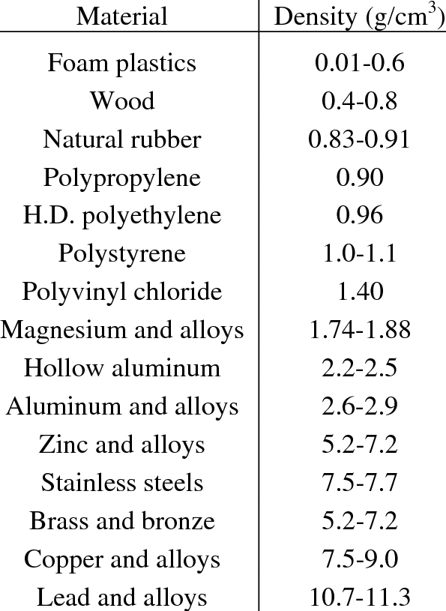
- What is the density of water? Remember units.
________________
- Use the table on the right to answer the following questions.
- What weighs more: a gram of foam or a gram of zinc? ________________
- What is more dense: a gram of foam or a gram of zinc? ________________
- In water, will foam float or sink? ________________
- In water, will zinc float or sink? ________________
- There is 30 mL of water in a graduated cylinder. When a rock is put into the water, it sinks, and the water level rises to 34 mL. What is the volume of the rock? Remember units and show your work.

- Calculate the density of a rock that weighs 8g and has a volume of 3 cm³. Remember units and show your work.

- Calculate the density of a piece of Styrofoam™ that has a volume of 50 cm³ and weighs 3g. Remember units and show your work.

- There is a graduated cylinder with 20 mL of water. A ring weighing 12g is dropped into the water and it sinks to the bottom, causing the water level to rise to 21.5 mL.
- What is the volume of the ring? Remember units and show your work.

- What is the density of the ring? Remember units and show your work.

- Compare the density you calculated in “b” to the table from question #5. What material is the ring most likely made out of?

