Name: _____________________________________ Date: ____________________ Block: _____
Mendel’s Peas Animation Activity

Background Information
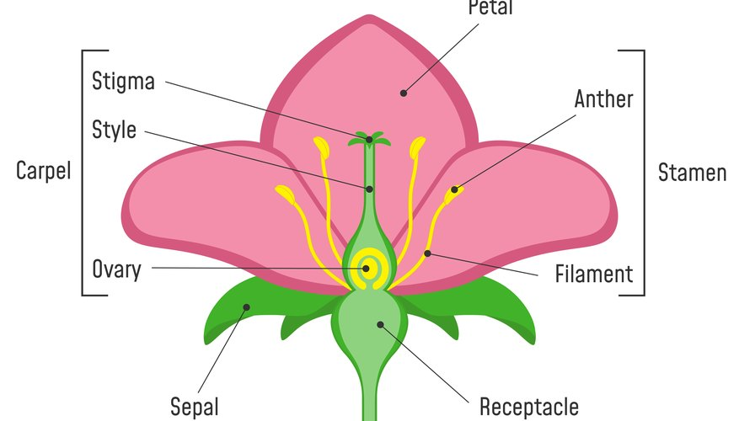
Sexually, pea flowers have both male parts (anthers, pollen) and female parts (stigma, ovary).
There are two ways pea plants can reproduce:
- Self-fertilization: The eggs are fertilized by its own pollen. (This is a form of sexual reproduction because it involves sperm and egg.)
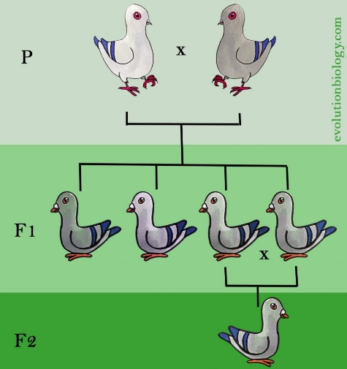
- Cross-fertilization: The flower is fertilized by another plant’s pollen.
(F₀)
F₀ (P) Generation: The parental generation. In Mendel’s experiments, his F₀ were always pure-breeding.
F₁ Generation: The offspring produced by the F₀ generation.
F₂ Generation: The offspring produced by the F₁ generation.

Pre-Lab Questions
- If you take a purple-flowered pea plant and cross it with a white-flowered pea plant, what do you predict the offspring will look like?
____________________________________________________________________________________
- If you take two purple-flowered pea plants and cross them, what do you predict the offspring will look like?
____________________________________________________________________________________

Instructions
- Go to the animation link below, which can also be found on Ms. Au’s website. https://www.newpathonline.com/api_player/enus_54_6208/2Lgdgi/index.html
- Click the “Learn More” link and watch the video 1-2 times until you have a good grasp of the ideas within.
- Run the simulation 5x for each of the choices of parental crosses. Record your findings in Table 1 on the following page.
- Use your Table 1 data to complete Table 2.

Complete Table 1 using data collected from the simulation.
Table 1: Raw data collected from 100 crosses per generation for four different traits.
 | Experiment 1 |  | Experiment 2 |  | Experiment 3 |  | Experiment 4 |  | Experiment 5
 | F₁ | F₂ | F₁ | F₂ | F₁ | F₂ | F₁ | F₂ | F₁ | F₂
White flower | 0 | 8 | 0 | 3
Purple flower | 20 | 12 | 20 | 17
Green pod
Yellow pod
Wrinkled seed
Round seed
Tall plant
(tip: has more flowers)
Short plant
(tip: has fewer flowers)

Complete Table 2 using data from Table 1.
Table 2: Summary table
 | Total F₁ Plants | % of F₁ Plants | Total F₂ Plants | % of F₂ Plants
White flower | How many F1 plants had white flowers? | Divide “Total F1 White-Flower Plants” by 100. | How many F2 plants had white flowers? | Divide “Total F2 White-Flower Plants” by 100.
Purple flower | How many F1 plants had purple flowers? | Divide “Total F1 Purple-Flower Plants” by 100. | How many F2 plants had purple flowers? | Divide “Total F2 Purple-Flower Plants” by 100.
Green pod
Yellow pod
Wrinkled seed
Round seed
Tall plant
Short plant

Questions

  - Describe the overall pattern you observe in the F₁ generation. What traits do the F₁ individuals have? In what proportions?
_________________________________________________________________________________
_________________________________________________________________________________
  - Describe the overall pattern you observe in the F₂ generation. What traits do the F₂ individuals have? In what proportions?
_________________________________________________________________________________
_________________________________________________________________________________

  - For experiment A, compare your F₁ and F₂ percentages with your classmates. Are they the same? Different? Why do you think this is?
_________________________________________________________________________________
_________________________________________________________________________________
  - Estimate the average F₁ and F₂ percentages for white and purple flower crosses.
F₁: __________% white flower and __________% purple flower
F₂: __________% white flower and __________% purple flower

- Compare your findings in this simulation experiment to your predictions on the first page of this activity. What, if anything, surprised you about your results from this simulation experiment?
_________________________________________________________________________________
_________________________________________________________________________________

