Name: ________________________________ Date: ____________________ Block: ________
Microscope Review Problems (Life Sciences 11)
Unit Conversions
- Complete the following unit conversions.
- 289 mm to cm  - 19.88 cm to m  - 9.6 µm to mm  - 5899022 nm to cm | - 980.22 µm to m  - 0.0082 m to mm  - 29607 nm to µm  - 890000 nm to cm | - 87000 µm to m  - 0.025 cm to µm  - 0.00051 mm to µm  - 0.0000012 µm to nm

Total Microscope Magnification
- On our microscopes, what is the magnification of a Low power objective lens? Medium? High?  - If an ocular lens (eyepiece) with a magnification of 16x was inserted into our microscopes, what would the total magnification be on Low power? Medium? High? | - Complete the following table.  Eyepiece Objective Total Magnification  10x 4x  15x Medium power  5x Low power  10x 100x  High power 400x

Field Number and Field of View
- What is the relationship between field number, field of view, and magnification of the objective? Write the formula.

- By looking at an eyepiece, how do you determine the field number?

- Complete the following table.
Eyepiece | Eyepiece A  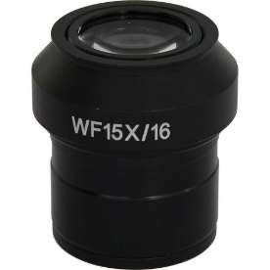 | Eyepiece B  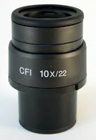 | Eyepiece C  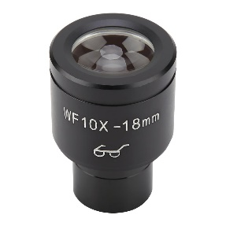
Eyepiece magnification
Field Number
Field of View on Low Power
Field of View on Medium Power
Field of View on High Power

- Estimate the size of the following. Eyepieces A, B, and C can be found in the previous question.
  - A cell that takes up 1/5 of a field of view on medium power with Eyepiece C.

  - A hair that takes up 1/3 of a field of view on high power with Eyepiece B.

- A student is looking at a slide with onion epidermis cells. If there are 70 cells lined up along the middle of the field of view, and the field of view is 3500 µm, what is the length of an average cell?

Drawing Magnification
- An amoeba on a mural is drawn to be 1.7 m in length. If the drawing magnification is 1800x, what is the actual size of the amoeba in mm? In µm? nm?

- Suppose the actual height of the elephant pictured on your textbook cover is 3.3 m. What magnification was the elephant drawn at?

- The HIV virus is round and measures 100 nm in diameter. Draw the HIV virus at a drawing magnification of 36,000 x. Label it with a horizontal, straight label.

Mixing Things Up

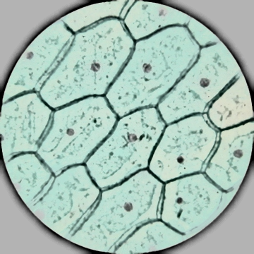
  - To the right is a drawing of plant cells viewed under a compound microscope. Estimate the actual size of one plant cell in the image, assuming it is viewed under low power using an eyepiece with a field number of 20 mm. Show all your work.

  - Suppose the actual width of one of the plant cells shown is 1.5 mm. Calculate the magnification of the drawing.

- A microscope’s objective lenses have the following magnification values: 5x on low, 15x on medium, 50x on high. The field of view under low power is 7 mm. Determine the field of view of this microscope under medium power, in both mm and µm.

- A specimen is 40 µm long. The specimen fits across the field of view 10 times under high power. Calculate the field diameter of this microscope.

