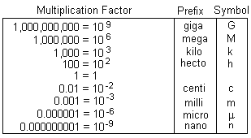
Name: _________________________________ Date: _______________________ Block: ______
Unit Conversions Tutorial (LSc11)
- Determine a conversion factor between your units.
Examples: ____ mm = ____ cm
____µm = ______ nm
____ km = _______________ cm
- Write your conversion factor as a fraction, with the desired unit on top and old unit on bottom.
- Multiply by the top part of the fraction and divide by the bottom part of the fraction. Express your answer with the new unit.
Example 1: Convert 79 mm to cm. | Example 2: Convert 540 nm to µm.

Practice:

- 22 cm to mm
- 1580 cm to m
- 58,960,000 nm to mm
- 0.0065 µm to nm
- 28 µm to mm
- 0.00003 m to nm
- 600 nm to µm
- 22,451 mm to µm
- 890 mm to m
Total Magnification
- Default magnifications (memorize!):

  - Eyepiece = 10x
  - Low objective = 4x
  - Medium objective = 10x
  - High objective = 40x
  - Oil immersion = 100x

- Compound microscopes have two lenses working together.
- To calculate the total magnification of a compound microscope, you must multiply the eyepiece magnification with the objective magnification.

Example 1: Calculate the total magnification of a compound microscope with a 15x eyepiece and a 40x objective.
Example 2: Calculate the total magnification of a compound microscope on medium power.

Example 3: Calculate the total magnification of a compound microscope on high power.
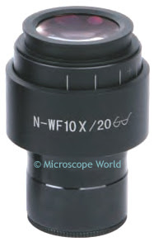
Eyepiece

This eyepiece has a magnification of 10x and a field number of 20 mm.

Every eyepiece has two values:
Magnification (of eyepiece lens only)
Field number:
  - The actual diameter of the circle being viewed
  - In millimeters (mm)
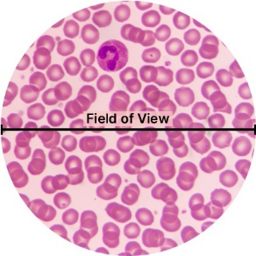
Field of View Calculations
Field of View: diameter of observable area when looking through a compound microscope

$$field of view=\frac{field number}{objective magnification}$$

Example 1: Calculate the field of view on high power objective. | Example 2: Calculate the field of view on low power objective. | Example 3: Calculate the field of view using an oil immersion lens (100x magnification). Convert your answer to micrometers.

Specimen Size: Daphnia
This is a water flea (Daphnia magna) on low power. If the eyepiece field number is 16mm, determine the length of the flea.

Specimen Size: Euglena
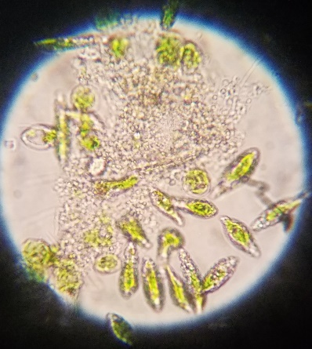
Euglena is a unicellular, eukaryotic, photosynthetic organism. It moves by rotating its whiplike flagellum.
This image was taken using a 10x objective lens and the eyepiece shown. Calculate the length of the labelled individual. Express your answer in micrometers.

