Name: ______________________________ Date: __________________________ Block: _______
Onion Root Tip Dry Lab (Science 9)
- Fill out the following comparison table for each of the stages of the cell cycle.
 | Nucleus (present vs absent) | What does DNA look like? (chromatin vs chromosomes) | Summarize what is happening in this stage.
Interphase
Prophase
Metaphase
Anaphase
Telophase
Cytokinesis
- Label the stages that you see here (interphase, prophase, metaphase, anaphase, telophase).
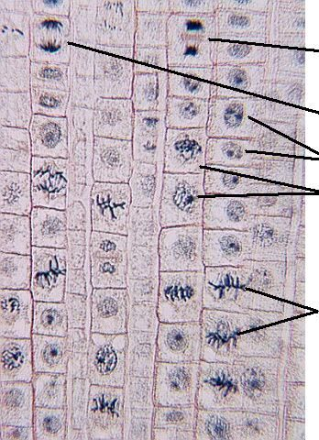
- Examine the cells that are in interphase. Describe what their nuclei look like, in your own words.

- How does interphase differ from the other phases? (What form is DNA in? How long does the stage last? What happens during this stage?)

- At any given moment, your cells are at different stages of the cell cycle. Some will be undergoing mitosis while others will not. What observation(s) can you make from this picture to support this? Explain.

  - Label the phases indicated by the arrows in the image below.
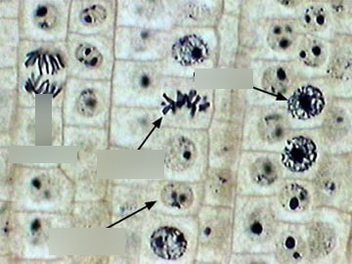
  - Which stage of the cell cycle is the most common? Why do you think this is?

- Which part of the onion root tip do cells undergo the most rapid cell division? Highlight it and explain what observation(s) led you to this conclusion.

