Microevolution Simulation: Mutation, Genetic Drift, and Natural Selection
Russo, C.A.M., Voloch, C.M. Beads and Dice in a Genetic Drift Exercise. Evo Edu Outreach 5, 494–500 (2012). https://doi.org/10.1007/s12052-012-0438-6
Materials:
- 30 “light” beans to start (white navy beans)
- 30 “dark” beans to start (soybeans or red beans)
- 1x six-sided die
- 2x petri dishes (line one with paper towel to represent your habitat; the other will store your spare beans that are not being used)

Rules of the Game:
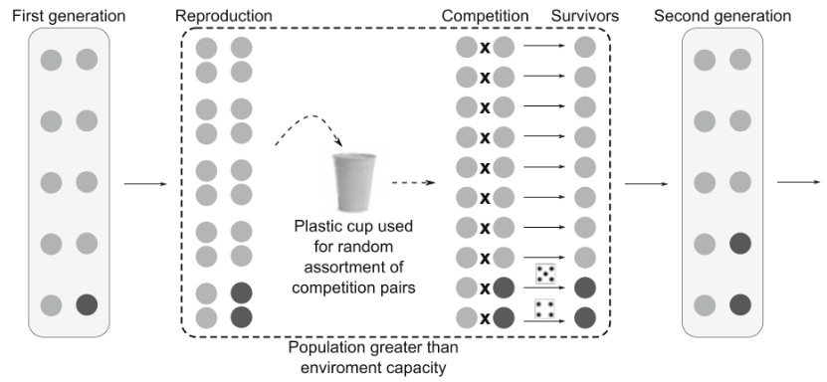
Each generation has two stages.
- Reproduction: Each individual reproduces by the designated rate. Default rate is 2 unless otherwise specified.
- Competition: Pair up beans by randomly drawing them from the Petri dish.
- For each pair of same colour beans, no need to roll. Pick one at random to survive.
- For each pair between different colour beans, roll a six-sided die. The winner will be determined by the outcome of the roll, according to the Competition Rules of that scenario.
Each scenario has its own carrying capacity: the maximum number of individuals that the environment can support. Competition will occur until the population has been reduced to the carrying capacity. Competition will not occur if the population is smaller than the carrying capacity (e.g. Scenario 6).

Scenario 1: Genetic Drift Only
A new mutation has arisen in a population. Set up 9 light beans and 1 dark bean to start. Carry out the reproduction and competition stages, recording the number of light and dark beans in each generation.
Competition Rules: Roll 1/2/3 = Light survives Roll 4/5/6 = Dark survives
Carrying Capacity: 10
 | Generation 1 | Generation 2 | Generation 3 | Generation 4 | Generation 5 | Generation 6
Dark | 1
Light | 9

- New mutations arise frequently due to chance errors in DNA replication. In this scenario, the new mutation caused a new trait: dark colour (instead of light colour). Explain the relationship between mutations and the variation that is required for natural selection to occur.
Scenario 2a: Natural Selection
The new mutant has a small selective advantage over the old variant.
Competition Rules: Roll 1/2 = Light survives Roll 3/4/5/6 = Dark survives
Carrying Capacity: 10
 | Generation 1 | Generation 2 | Generation 3 | Generation 4 | Generation 5 | Generation 6
Dark | 1
Light | 9

Scenario 2b: Natural Selection, Cont.
The new mutant has a significant selective advantage over the old variant.
Competition Rules: Roll 1 = Light survives Roll 2/3/4/5/6 = Dark survives
Carrying Capacity: 10
 | Generation 1 | Generation 2 | Generation 3 | Generation 4 | Generation 5 | Generation 6
Dark | 1
Light | 9

- In scenarios 2a and 2b, which organism has a higher fitness: light-colour, dark-colour, or neither? Explain briefly.

- Why might it be expected that evolution by natural selection would occur more quickly in scenario 2b than in scenario 2a? Explain briefly.

- What is more likely to occur: light colour becoming most common, or dark colour becoming most common in the population? Explain, using the word ‘fitness’ in your answer.

- Look at your answer for the previous question. Is it possible for the opposite to occur? Explain.

Scenario 3: Fertility Differences
Competitive abilities are the same, but one variant reproduces faster than the other.
Competition Rules: Roll 1/2/3 = Light survives Roll 4/5/6 = Dark survives
Carrying Capacity: 10
Advanced Competition/Reproduction Rules:
- In the reproduction phase, every Light bean results in 2 offspring (i.e. add 1 more Light to the pool); Every Dark bean results in 4 offspring (i.e. add 3 more Dark to the pool).
- In the competition phase, you may end up with more than 10 in the pool. If that is the case, then select additional competition pairs at random until the total number of beans is 10.
  - E.g. if you have 14 in the pool, select 4 more pairs at random to do the competition.
 | Generation 1 | Generation 2 | Generation 3 | Generation 4 | Generation 5 | Generation 6
Dark | 1
Light | 9

- What is more likely to occur: light colour becoming most common, or dark colour becoming most common in the population? Explain, using the word ‘fitness’ in your answer.

- Look at your answer for the previous question. Is it possible for the opposite to occur? Explain.

Scenario 4: Colonizing a New Environment
A small number of individuals breaks off and forms a new colony in a new environment.
Competition Rules: Roll 1 = Light survives Roll 2/3/4/5/6 = Dark survives
Carrying Capacity: 10 (Important: only do competition if the population exceeds the carrying capacity of the new environment.)

 | Generation 1 | Generation 2 | Generation 3 | Generation 4 | Generation 5 | Generation 6
Dark | 1
Light | 2

- The competition rules for this scenario were identical to Scenario 2b. Yet, the evolution progressed differently. Use your findings from Scenario 4 to describe how colonizing a new environment can cause deleterious (harmful) alleles to remain in a population.

Scenario 5: Changing Environment
A new mutation has arisen in a population. Set up 9 light beans and 1 dark bean to start. Carry out the reproduction and competition stages, recording the number of light and dark beans in each generation.
Competition Rules: Depends on the generation number. The environment is changing gradually, becoming brighter and brighter over time.
Carrying Capacity: 10
 | Competition Rules (Gen 1-2)  Roll 1/2/3 = Light survives  Roll 4/5/6 = Dark survives |  | Competition Rules (Gen 3-4)  Roll 1/2 = Light survives  Roll 3/4/5/6 = Dark survives |  | Competition Rules (Gen 5-6)  Roll 1 = Light survives  Roll 2/3/4/5/6 = Dark survives
 | Generation 1 | Generation 2 | Generation 3 | Generation 4 | Generation 5 | Generation 6
Light | 9
Dark | 1

