Science 8 Notes + Lesson Plan (Dec 10, 2019)

Warm-up Question:
- What kind of information is important to a crime scene investigator? What kind of information do they collect and why?

Qualitative vs Quantitative Observations
Qualitative Observations:
- Use your 5 senses (sight, smell, touch, hearing, taste) to observe the results.
- Descriptive, focuses on quality comparisons
  - E.g. “softer than”, “slower than”, “stringy”, etc.
- Subjective, may vary from person to person
  - E.g. colourblind observer will see differently
  - E.g. different people will choose different descriptive words
- Examples:
  - Cold to the touch, very fast, sinks to the bottom of a cup of water, pink
QuaNtitative Observations:
- Made using instruments such as rulers, balances, graduated cylinders, beakers, thermometers
- Measurable (numbers)
- Objective (less potential for human error)
- Examples:
  - 5ºC, 100 km/h, 3 g/mL, light with 700 nm wavelength
NOTE:
- Can describe the same thing with both types of observations
- Should describe things in as many ways as possible, using a combination of observation types: the more data the better!
  - Easier to graph quantitative observations, but qualitative ones are usually important for context

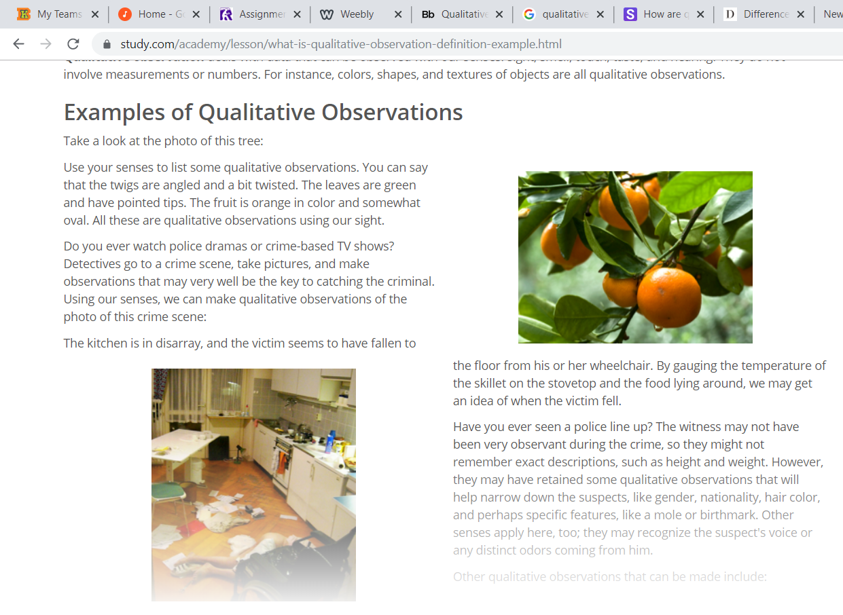
https://study.com/academy/lesson/what-is-qualitative-observation-definition-example.html

