PHET Charges and Charged Objects Investigation
Name Partners:__________________ Date
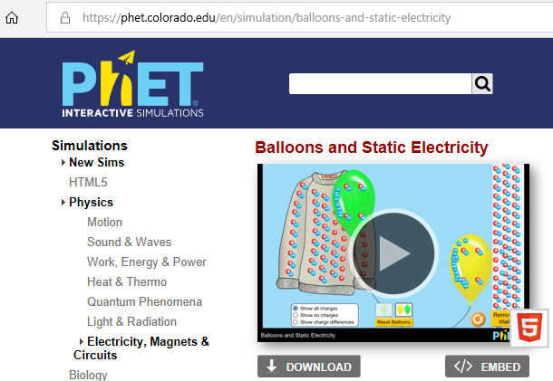
Charge Interaction:
Google “PHET Balloons and Static Electricity”
Or enter https://phet.colorado.edu/en/simulation/balloons-and-static-electricity
Insure there is a ‘5’ in the bottom right corner. Press play.

Pre-Charge
Put the balloon near (BUT NOT TOUCHING) the wall. Leave about as much space as the width of your pinky finger between the balloon and wall.
- Does the balloon move, if so which way? ___________________________________
- Do the protons (positive red circles) move in either object? if so how? _________________
- Do the electrons (blue negative circles) move in either object? if so how? __________________
- Did either the electrons or protons move from one object to the other? If so describe. _____________
Put the balloon near (BUT NOT TOUCHING) the sweater (gray shirt). Leave about as much space as the width of your pinky finger between the balloon and wall.
- Does the balloon move, if so which way? ____________________
- Do the protons (positive red circles) move in either object? if so how? ___________________
- Do the electrons (blue negative circles) move in either object? if so how? ____________________
- Did either the electrons or protons move from one object to the other? If so describe. ____________________
Section Questions
Q1. Did anything move in either of the above set ups? If so what? ___________________________________
Q2. What would you consider the overall charge of each object (circle)
Sweater | Positive (+) | Neutral | Negative (-)
Balloon | Positive (+) | Neutral | Negative (-)
Wall | Positive (+) | Neutral | Negative (-)

Q3. Even though there are neutral objects, do those objects still have positives and negatives inside? ________________________
Q4. For neutral objects, what do you notice about the number of positive and negative circles inside? ________________________
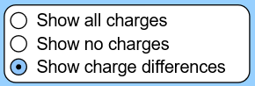
Q5. Change from ‘ Show all charges’ and click ‘Show charge differences’ what happens? ___________________________________
______________________________________________________________________________

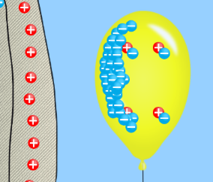
Charging an Object
Go back to SHOW ALL CHARGES. RUB the balloon over the sweater, it should look similar to the image to the right when you are done. You have now charged the balloon.
- What type of charge moved from one object to another? _____________________________
- What object gained electrons? ________________________________
- What object lost electrons? ______________________________
- Change from ‘Show all charges’ and click ‘Show charge differences’ . What is the charge of each object?
Sweater | Positive (+) | Neutral | Negative (-)
Balloon | Positive (+) | Neutral | Negative (-)
Wall | Positive (+) | Neutral | Negative (-)

- Complete this sentence: Objects that gain electrons, like the balloon, gain a charge. Objects that lose electrons, like the sweater, gain a charge. Objects that have the same number of electrons and protons, like the wall, have a charge.
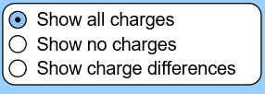
Interacting with a Charge
Go back to ‘Show all charges’
Put the balloon near (BUT NOT TOUCHING) the wall. Leave about as much space as the width of your pinky finger between the balloon and wall.
- Does the balloon move, if so which way? ___________________________________________________________________
- Do the protons (positive red circles) move in either object? if so how? ___________________________________________
- Do the electrons (blue negative circles) move in either object? if so how? _________________________________________
- Did either the electrons or protons move from one object to the other? If so describe. ______________________________
Put the balloon near (BUT NOT TOUCHING) the sweater (gray shirt). Leave about as much space as the width of your pinky finger between the balloon and sweater.
- Does the balloon move, if so which way? __________________________________________________________________
- Do the protons (positive red circles) move in either object? if so how? ___________________________________________
- Do the electrons (blue negative circles) move in either object? if so how? ________________________________________
- Did either the electrons or protons move from one object to the other? If so describe. _____________________________
Section Questions
Q1. Between ATTRACT, REPEL, AND NOTHING, what interaction occurred between the positive sweater and the negative balloon?
________________________________________________________________________________________________________
Q2. Between ATTRACT, REPEL, AND NOTHING, what interaction occurred between the neutral wall and the negative balloon?
________________________________________________________________________________________________________
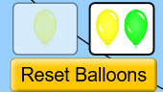
Q3. Reset balloons and select the two-balloon option. Get both balloons negative and try to bring them next to each other, what happens?
________________________________________________________________________________________________________
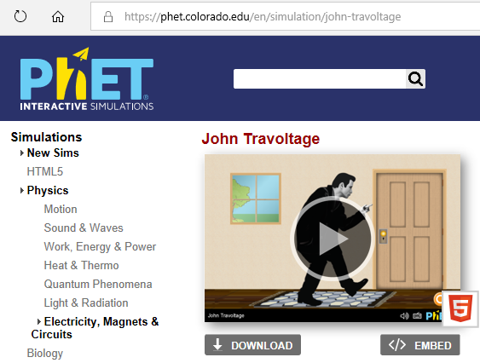
Google “PHET John Travoltage”
Or enter https://phet.colorado.edu/en/simulation/john-travoltage
Insure there is a ‘5’ in the bottom right corner. Press play.

- Grab and move the hand, does anything happen?

- Lift the hand/finger away from the door knob and point it up. Grab and move the foot on the carpet, what happens?

- Move the foot faster and faster, what happens?

- What charge is the person becoming?

- The more you rub the carpet the (stronger/weaker) the charge becomes.

- Touch the door knob. What happens?

- What takes less time, building up the electrons in the person by rubbing, or discharging (losing) the electrons when touching the door knob?

- Why do you think the electrons interact only on a single point on the body when this happens?

- How might the above two answers explain why a static shock may hurt a little? Explain in your own words.

Objects can become charged by three main processes; Charging by Friction, Induction, and Conduction. READ BELOW and then answer the final questions. These will be starting, working definitions and will be refined as the unit continues.
Charing by Friction is when you have objects rub against each other and in doing so the electrons of one object become close to the protons of another. If one of the objects is stronger at pulling electrons (electron affinity) it can steal the electrons from the other object as they rub. This tends to be seen with non-conductive objects like plastics, carpet, clothes, etc…
Charging by Induction is when two conductive objects, such as two metal objects, are touching. A third charged object is brought near the other two. The charged object will pull (if positive) or push (if negative) charges from one of the two touching conductive objects to the other. If the two objects are separated while their electrons are pushed/pulled onto the other object the objects will stay charged. This will happen as the electrons will be trapped on one object and missing from the other once separated.
Charging by Conduction A charged object is brought to touch a conductive object. As the object is conductive the excess charges will flow from on object onto the other.
Neutral objects can be attracted to other objects through a process called Polarization. In polarization the total number of charges doesn’t change. However, the electrons are pushed or pulled to one side of the object. This makes the side where the electrons are pushed/pulled to become temporarily negative and the side with the protons left in excess to be temporarily positive. The positive side will thus stick to a negative object and the negative side will stick to positive objects. Once the charge object is removed, the object returns to being a normal neutral object.

Last Questions
Q1. Did the person in “John Travoltage” become charged by friction, induction, or conduction?

Q2. In the first lab, did the balloon become charged by friction, induction, or conduction?

Q3. Think of the balloon and sweater. For one object (like the balloon) to become negative it means another object (like the sweater) must become equally what?

Q4. Look back at the Balloon lab. Charged moved in this lab between objects, did the TOTAL number of charges ever change?

Q5. What object showed polarization from either activity?

Q6. After reading the definitions and seeing the lab, explain how polarization allows for the negative balloon is attracted to the neutral, but polarized, wall.

Q7. What needs to happen for an object to have a negative charge?

Q8. What needs to happen for an object to have a positive charge?

Q9. An object is neutral, does this mean it has NO electrons and NO protons?
Q10. Defend your answer above and explain why it is yes or no.

Math and Charges
Q11. An object has 4 positive charges and 2 negative charges. What is its total charge?
Q 12. An object has 30 positive charges and 30 negative charges. What is its total charge?
Q 13. An object has 13 positive charges and 16 negative charges. What is its total charge?
The real value of a charge is not +2 or -3, but is measured in Coulombs ( C ). This is a multiple of the excess electrons or protons the object has. The magnitude of the charge of one electron or one proton is approximately (1.6 x 10⁻¹⁹ C). If you have 3 extra electrons you would multiply 3 x (1.6 x 10⁻¹⁹ C) to find the magnitude of the charge on the object. If it has extra electrons this value would be negative for the charge and excess protons would be a positive value.
Q 14. An object has 6 protons and 8 electrons. Calculate the magnitude of the charge on the object.

Q 15. If an object has a total negative charge of (4.8 x 10⁻¹⁹ C), how many extra electrons does it have?

