Names: ____________________________________________________________________________ Block: __________
Presentation Date: ___________________________________
Biodiversity Presentation (Life Sciences 11)
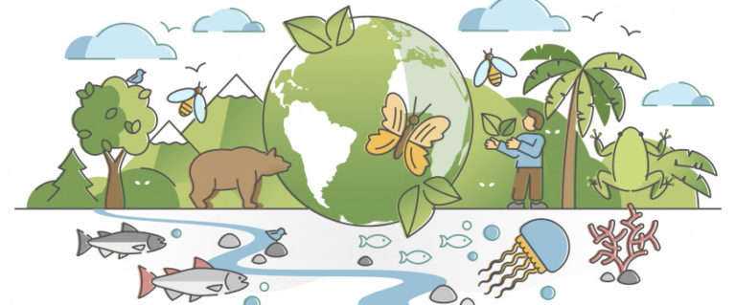
We have only barely scratched the surface of taxa in the biosphere. This project is meant to introduce you to the remaining taxa that we have not had time to cover in this course.
You will, in groups of 3-4, make a presentation (approximately 5-10 minutes long including the activity: ask for pre-approval if you will go over this limit) that describes a phylum/subphylum/class in Kingdom Animalia. The options are as follows:

Flatworms  Platyhelminthes | Cartilaginous Fish  Chondrichthyes
Roundworms  Nematoda | Boned Fish  Osteichthyes
Segmented Worms  Annelida | Amphibians  Amphibia
Arthropods  Chelicerata and/or Arachnida  Crustacea  Hexapoda and/or Myriapoda | Reptiles  Squamata  Crocodilia  Chelonia
Echinoderms  Echinodermata | Birds  Aves

Required Components
- Defining characteristics of the taxon
  - Life Cycle
  - Mode of Locomotion
  - Environment/habitat it lives in
  - Body Plan
    - General shape, characteristics (e.g. head, tail, etc.)
    - Pick three:
      - Digestive System
      - Nervous System (overall structure and specific sensory organs)
      - Reproductive System
      - Circulatory System
      - Respiratory System
- Elaborate on (at least) 3 representative species. For each species, you will need:
  - Name of species and its scientific name
  - Meaning and/or origin of the genus and species names
  - Photos
  - Cool facts (at least one)
- An interactive activity that can be completed by the class
  - Fairly open-ended, but should either summarize the content you covered in your presentation (e.g. kahoot, crossword) or enhance the audience’s understanding of a topic (e.g. demonstration, skit, etc.)
- Reference list (in MLA formatting)
  - All sources of information must be properly cited in MLA formatting
- Image reference list (URLs okay)
  - All image/video sources must be included in the presentation. URLs may be listed directly underneath the images/videos or may be listed at the end.

Notes
Your presentation is meant to be an introductory overview of key concepts, not a comprehensive ‘teaching’ presentation.
You will likely discover that there is more information than can possibly be covered in your presentation. Feel free to simplify the information and emphasize the parts that you find most interesting or exciting. You do not have to re-explain concepts that have already been taught (e.g. you can say it has bilateral symmetry without explaining what that means).
Your presentation can be done in any order, as long as you have all the required components.
Marking Scheme
Category | Points Possible
Content (group)  - All required components are present (including interactive activity)  - Research is thorough and complete  - Content adapted appropriately for a gr 11 context | 0 | 2 | 4 | 6 | 8
Citations  - At least 3 different sources of information used (not including images)  - All information sources are correctly formatted in MLA  - Image/video sources are included | 0 | 1 | 2
Group Cohesion: (group)  - Equal participation by all group members  - Transitions between speakers are smooth  - Presentation is organized and flows logically  - Effective use of in-class time | 0 | 1 | 2 | 3 | 4
Use of Visual Aids (group)  - Presentation is visually appealing and well-organized | 0 | 1 | 2 | 3 | 4
Interactive Activity (group)  - Effectively summarizes content AND/OR enhances audience’s understanding of topic | 0 | 1 | 2 | 3
Presentation Skills (individual)  - Rehearsed  - Not reading off visual aid  - Information is in own words  - Voice loud and clear  - Knowledgeable, presents content well | 0 | 1 | 2 | 3 | 4
Total | /25

Note: In the case of unequal distribution of work within a group, marks may be adjusted to reflect the contributions of individual group members.

