Names: _____________________________________________ Date: ___________ Block: ________
The Ray Model of Light (Science 8)
Activity 1: The Ray Model
Shine the laser pointer through the entire length of the rectangular block.
- Draw what you see below.

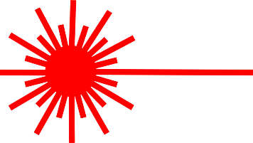

- Describe your observations in one or two sentences.
_____________________________________________________________________________
_____________________________________________________________________________
_____________________________________________________________________________
Activity 2: Fun with Ray Boxes
Plug in your ray box and experiment with how the different slit attachments affect the light that is cast onto the table.
- Draw your observations below.
Single Slit  Ray Box | Three Slits  Ray Box
Five Slits  Ray Box | Wide Slit  Ray Box

- What does the “ray model of light” state? Explain how your observations from activity 1 support this model.
_____________________________________________________________________________
_____________________________________________________________________________
_____________________________________________________________________________
Activity 3: Hold a Candle to Me!
Light the candle and set up your experiment as shown below.
Cardboard
Paper

- Place the candle fairly close to the cardboard (about 3 cm away). One of your group members should watch the cardboard carefully at all times to ensure it does not catch fire accidentally.
- Observe the image of the candle flame on the white piece of paper. Does it appear to be right side up or upside down? ____________________________________________________
- Draw the image of the flame on the ‘piece of paper’ in the diagram above. Then, draw straight lines (to represent light) from the candle through the hole onto the sheet of paper.
- How does this experiment give evidence to support the idea that light travels in straight lines?
_____________________________________________________________________________
_____________________________________________________________________________
- Observe what happens to the size of the flame ‘picture’ projected on the white sheet of paper when you:
- Move the cardboard towards the candle (but not too close!)
_____________________________________________________________________________
_____________________________________________________________________________
- Move the cardboard away from the candle
_____________________________________________________________________________
_____________________________________________________________________________

