Science 9 Pathways Inquiry Project
Research Paper:
The research paper is where you will explain all the preparation, research, and thought that went into your science experiment. You will use your results to answer your research question. Outlined below are the sections that should be included in your research paper.

1. Introduction: In the introduction, you will introduce your overall topic (plant growth), describe the bigger picture of why it is important (and give some research to back this up), and then narrow down your focus to your specific plant species and your specific experiment (the independent variable you chose).
In the second half of your introduction (when narrowing your focus), make sure to include:
- Background research about factors that can affect your dependent variable in plants
- Why you chose your specific independent variable(s) to investigate; the importance of your independent variable(s)
- Testable Question
- Research you did on the effect of your independent variable(s) on your dependent variable; this research should lead directly to your hypothesis
- Hypothesis

2. Experimental Design: This is where you explain what you did, and why you did it that way. You will also explain any adjustments you were forced to make to your experimental design along the way.
- Diagram of experiment (with control/treatment groups and # of plants in each group)
- Procedure (step by step, with pictures)
- Describe how you set up your experiment
- Describe how you controlled for and/or measured different variables in the experiment. Support your decisions with research and/or logical reasoning
- Describe how you took measurements of your dependent variable
- How you cared for your plants

3. Results:
- Key graph(s) and figures that show your results. Each graph and figure should have a figure number and caption. See example below.
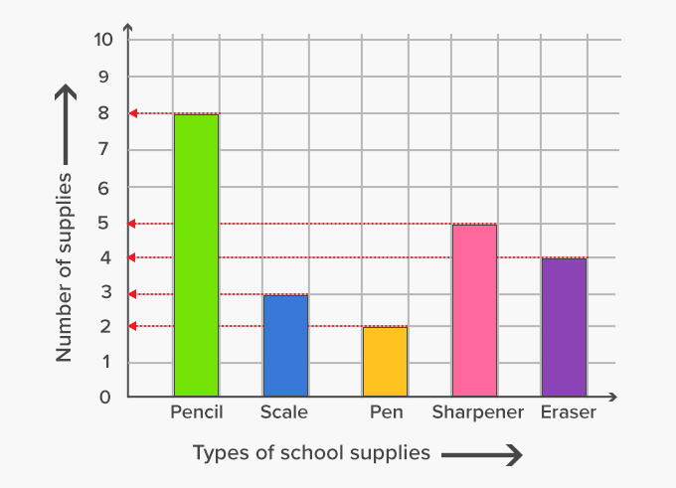
Figure 1. Quantities of school supplies that Gr 9 students reported having in their pencil cases at the start of the experiment.
- Describe your results using words:
  - Describe any qualitative observations you made that you thought were important.
  - Describe what is shown in your graph and say whether a significant difference was found based on the statistical analysis. Stick to the data: do not speculate or interpret the data yet.
4. Discussion: The discussion is where you will take your results and interpret them.
- Explain what your results mean. Did your results support or disprove your hypothesis? Did your results align with what you thought would happen, or did they surprise you? Do research to discover possible explanations for why you found what you found.
- Discuss possible errors. What do you think might have gone wrong that affected your experiment or your results? What would you have done differently if you could redo this experiment? Were there any confounding variables that may have affected your experiment?
- Future directions for research. What are the bigger implications of what you found? What other testable questions would you like to investigate, following from this experiment?

5. Conclusion (copied from GVRSF manual):
The conclusion is not just a summary of your results; it is the answer to your [testable] question. It is what you have shed sweat and tears, and possibly blood, for over the past few months. So, write it wisely. You are tremendously proud of what you have written! So display it to your audience clearly and to-the-point. You don’t want to hide your genius discoveries behind run-on sentences and poetic verses. You want to very simply tell your audience: “This is what I found and it tells me that my hypothesis is true/false. From this I learned that …”

6. Bibliography (MLA format): Cite all research used. Use an online guide for how to cite using MLA.
In addition to your bibliography, you should be referring to this research specifically throughout your paper. There are two ways to do this. Pick one:
Use the first names of the authors and/or the website names. Examples:  - In Henry Chauvsky’s paper, it was found that…  - According to the Brittanica article on Marigolds…  - The APA website says that…  - https://msauscience.weebly.com/uploads/1/2/2/2/122210100/r1-version2-l13.pdf  For more examples, do an internet search for “in-text citations” or “in-line citations”. No need to format these correctly; it is just to get into the habit. But if you want, you can look up the “correct” MLA way to do in-text citations. | Number each resource in your bibliography. Refer to the numbers as you go. Example: http://msauscience.weebly.com/uploads/1/2/2/2/122210100/swimming_speed_microbes.pdf

Evaluation
The research paper will be marked according to the following general criteria, as well as the learning map on the next page.

General criteria for research paper:
- Contains all required components as outlined in this document; is accurate and complete
- Is proofread and free of mistakes
- Paper is well-organized and flows well; your thinking is easy to follow
- Paper includes relevant images and figures, with captions
- Should be minimum 2.5 pages (single-spaced, 11 or 12 pt font), including figures from the results section. No maximum.

 | Extending | Proficient | Developing | Emerging
Introduction | Captivates the reader and convinces them that the experiment is worthy of investigation  Flows well from bigger-picture implications of the research to more specific details of the experiment | Sufficient background information is provided for the reader to understand the purpose and importance of the experiment | Some background information is provided, but may leave reader wondering about the purpose or importance of the experiment | Introduction absent or incomplete
Experimental Design | Consistently and accurately identifies and distinguishes between independent, dependent, and control variables.  Experimental design is controlled and takes steps to avoid or minimize the effect of confounding variables  Procedures are clear, concise, and contain enough detail as to be reproducible; thorough schematics of lab set-up included where relevant  Systematically records all relevant observations in an organized manner | Identifies and distinguishes between independent, dependent, and control variables  Experimental design is generally sound but may overlook several minor control variables  Procedures are clear and complete, but may require more detail in places; schematics of lab set-up included where relevant  Records many relevant observations | Identifies variables but struggles to distinguish between the types of variables  Experimental design is generally sound but overlooks key control variables  Procedures mostly complete but not reproducible: important details and instructions have been overlooked  Records minimal observations | Struggles to conceptualize variables  Has great difficulty designing a single-variable experiment, even with support  Procedures incomplete or incoherent  Records too few or irrelevant observations
Results | Displays numerical data and observations using appropriate tables and graphs that are accurate and well-formatted, with attention to detail  Interprets and draws accurate and appropriate conclusions from visual representations of data  Results are described and discussed (perhaps in Discussion) in a way that indicate a sufficient understanding of the statistical analysis | Displays numerical data and observations using appropriate tables and graphs  Interprets and draws appropriate conclusions from visual representations of data  Data are reported by correctly using the provided template; an attempt has been made to describe the data using the statistical analysis | Displays numerical data and observations using mostly appropriate tables and graphs that may be lacking in detail or organization  Describes overall trends in data (e.g. “the volume increases”) that may not be scientific or represent the big picture  Data are reported using the provided template, with some errors | Has limited success using graphs and tables to display data and observations  Describes basic trends in data (e.g. “the line goes up”) that are disconnected from the overall purpose of the data representation
Discussion and Conclusion | Uses data and supplemental research to answer the testable question and explore the greater implications of the investigation in a masterful way  Reflects upon the experimental design process, discussing any meaningful errors and flaws in the design | Uses data and supplemental research to answer testable question in a satisfying way  Discusses errors and flaws in experimental design and how they might have affected the experiment | Link between data and testable question is unclear  Discussion of error is simplistic and not well-explained | Discussion/conclusion absent or incoherent
Bibliography and Citations | Research paper consistently refers to specific sources throughout the text.  All works are cited correctly according to MLA format | Research is referred to sporadically or non-specifically throughout the research paper.  All works are cited correctly according to MLA format | Works are listed in the bibliography but not cited using MLA format | No citations included

Presentation:
The presentation is where you will tell the story of your research, and try to ‘sell’ its importance to your audience. Give background information for why you decided to conduct your experiment, in an engaging way. Explain your experimental methods, but don’t get bogged down in the research or in the details. Communicate your results and share your conclusion(s) with your audience.

Guidelines and Recommendations:
- 5-10 minutes long + time for questions
- Avoid very wordy slides. Avoid reading off your slide (or your cue cards). Use videos and images to capture your audience’s attention.
- No requirement for sections that need to be in the presentation, but can base it loosely off of the research paper.
- Practice the presentation all together as a group. Practice pointing to elements of your powerpoint.
- Run your presentation by Ms. Au ahead of time. She will give you feedback.
- (Need somewhere to practice or work as a group? You may work in Ms. Au’s room [nearly] every day after school until 5PM.)

Evaluation:
The presentation will be evaluated according to two sets of criteria.
After each presentation, your classmates and teacher will score your group on the following on a 4-point scale:
- Includes all group members
- Is well organized and rehearsed
- Is engaging and interesting; draws the audience in and keeps their attention
- Describes the why (background info) and how (methodology) in sufficient detail

Ms. Au will also score you on the following individual criteria on a 4-point scale:
- Speaks clearly and confidently
- Refers effectively to visual aids; does not read off slide or cue cards
- Well-rehearsed
- Is knowledgeable and responds appropriately to questions posed about the project

