Science 9 Pathways Results Elaboration
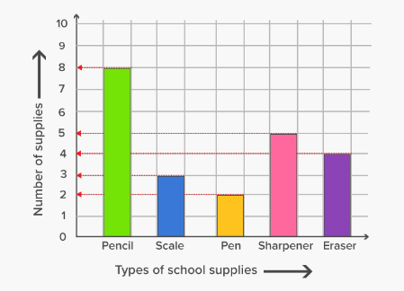
1. Key graph(s) and figures that show your results.
  - Each graph and figure should have a figure number and caption. See example on the right.
  - Check that your graph has the following:
    - Title
    - Axis labels
    - Legend (if necessary)
    - Error bars showing standard deviation
Figure 1. Quantities of school supplies that Gr 9 students reported having in their pencil cases at the start of the experiment.

    - Is visually appealing and easy to interpret
2. A description of results using words.
- Describe any qualitative observations you made that you thought were important.
- Describe what is shown in your graph and say whether a significant difference was found based on the statistical analysis. Stick to the data: do not speculate or interpret the data yet.
Suppose Ms. Au is studying the effect of sugar [independent variable] on Gr 9 test performance [dependent variable]. Ms. Au does a study of 4 students and concludes that when she gives them candy before a test, they perform 50% better. The problem? Look at her data.
Control (no candy) |  | Experimental (candy)
Student | Score on Test | Student | Score on Test
Student #1 | 10% | Student #1 | 100%
Student #2 | 30% | Student #2 | 0%
Average | 20% | Average | 50%

On average, they do perform better. But is the average good enough? You can see that one student with candy did better but another one did worse than the average for the control group. This is where statistical analysis comes in…to figure out whether any differences you observe are meaningful or not.
You will complete an Excel tutorial with Ms. Au and learn how to calculate averages and standard deviations, then plot them on your graph.
Use the following template to help you report your results. For those of you with more than 2 bars on the same graph, you will have to repeat this template multiple times until you have compared all the bars to each other.
 | Significant difference (error bars do not overlap) | No significant difference (error bars overlap)
1st sentence | [Independent variable] had a significant effect on [dependent variable]. | [Independent variable] had no effect on [dependent variable].
2nd sentence | There was a significant difference between [dependent variable] at/of [first treatment level of independent variable] (average ± standard deviation) and [dependent variable] at [second treatment level of independent variable] (average ± standard deviation). | There was no significant difference between [dependent variable] at/of [first treatment level of independent variable] (average ± standard deviation, with units) and [dependent variable] at [second treatment level of independent variable] (average ± standard deviation, with units).

Example 1:
If I was doing a study on the effect of sex (independent variable) on body mass of rabbits (dependent variable):
 | Sex | Body Mass (kg)
1 | M | 3.1
2 | M | 3.5
3 | M | 3.9
Average |  | 3.5
Stdev |  | 0.4
 | Sex | Body Mass (kg)
1 | F | 2.0
2 | F | 2.4
3 | F | 2.2
Average |  | 2.2
Stdev |  | 0.2

We found that in rabbits, body mass was significantly affected by sex. (Or; “Sex had a significant effect on the body mass of rabbits”).
There was a significant difference between body mass of female rabbits (2.2 ± 0.2 kg) and body mass of male rabbits (3.5 ± 0.4 kg).

Example 2:
The effect of sugar [independent variable] on Gr 9 test performance [dependent variable].
Control (no candy) |  | Experimental (candy)
Student | Score on Test | Student | Score on Test
Student #1 | 10% | Student #1 | 100%
Student #2 | 30% | Student #2 | 0%
Average | 20% | Average | 50%
Stdev | 14% | Stdev | 71%

In conclusion, we found that candy had no significant effect on students’ test scores.
There was no significant difference between test scores of students with candy (50±71%) and test scores of students without candy (20±14%).

More Examples:
- https://msauscience.weebly.com/uploads/1/2/2/2/122210100/mouse_frog_working_draft4.pdf Results section
  - Fairly straightforward bar graph.
- https://msauscience.weebly.com/uploads/1/2/2/2/122210100/r1-version2-l13.pdf Results section
  - It looks scary, but really there is only a small paragraph written up for each of the figures. It compares error bars: those with significant differences are those whose error bars do not overlap. Those without significant differences are those whose error bars do overlap.

