Name: _____________________________________________ Date: _____________________ Block: __________
Series and Parallel Circuits Lab
Purpose: Describe the relationship between potential difference, current, and resistance for series and parallel circuits.

Instructions:
Step 1) Go to “Phet - Circuit Construction Kit: DC” simulation
https://phet.colorado.edu/en/simulations/circuit-construction-kit-dc. Press play and select “Lab”.
Step 2) Play around and try to learn how to use the simulation (how to connect, disconnect, change values of a circuit element, how to use voltmeter and ammeters) for 5 minutes.

Part 1: Ammeter and Voltmeter Tutorial
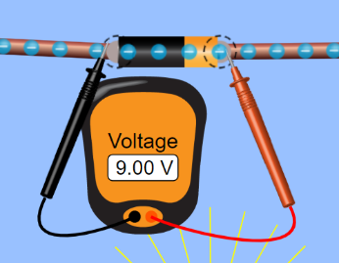
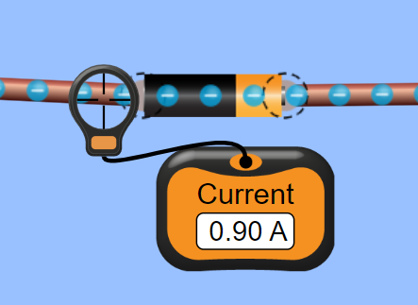
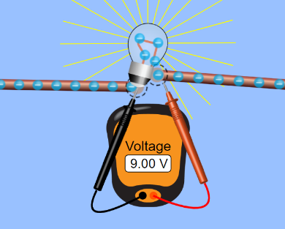
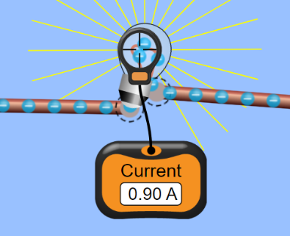
Step 3) Make a simple circuit with a default 9.00V battery and one default light bulb (10 ohms). Make the following measurements using an ammeter and a voltmeter. Your measurements should match what is shown in the diagrams.
To measure potential difference across a single lightbulb (e.g. V₁, V₂, V₃), place the black probe to one end and place the red probe to the other end of the lightbulb.
To measure the current through a lightbulb (e.g. I₁, I₂, I₃), place the center of the circular probe on the wire inside the lightbulb.
To measure the total current through the circuit (I_{tot}), place the center of the circular probe on the wire right after the battery.
To measure total potential difference across the circuit (V_{tot}), place the black probe on one end of the battery and the red probe on the other end of the battery.

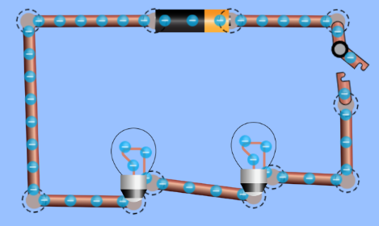
Part 2: Series Circuits
1
2
Step 4) Construct the circuit on the right. It has two light bulbs in series. Set the battery to 60V and resistance of the lightbulbs to 10 ohms each.
Step 5) Use the voltmeter and ammeter to measure the voltage and current across each light bulb. Record your results in Table 1.
(V₁ = voltage of first light bulb; I₁ = current of first light bulb;
V₂ = voltage of second light bulb; I₂ = current of second light bulb; etc.)
Table 1: Voltage and Current in a Series Circuit with up to Four Lightbulbs
 | Entire Circuit |  | Lightbulb #1 |  | Lightbulb #2 |  | Lightbulb #3 |  | Lightbulb #4
 | V_{tot} | I_{tot} | V₁ | I₁ | V₂ | I₂ | V₃ | I₃ | V₄ | I₄
Step 4  (2 bulbs) | 60 V | ____ A | ____V | ____ A | ____V | ____ A | N/A | N/A | N/A | N/A
Step 5  (3 bulbs) | 60 V | ____ A | ____V | ____ A | ____V | ____ A | ____V | ____ A | N/A | N/A
Step 6  (4 bulbs) | 60 V | ____ A | ____V | ____ A | ____V | ____ A | ____V | ____ A | ____V | ____ A

Step 5) Next, add one more lightbulb with 10 ohms of resistance in series to the circuit. Measure the voltage and current across each light bulb. Record your results in Table 1.
Step 6) Lastly, add one more lightbulb with 30 ohms of resistance in series and record the measurements in Table 1.

3. How does the speed of electron movement change when more lightbulbs are added in series?

4. How does lightbulb brightness change when more lightbulbs are added in series?

5. What is the relationship between the total current of the circuit and individual lightbulb currents in series?

6. What is the relationship between the total voltage of the circuit and individual lightbulb voltages in series?

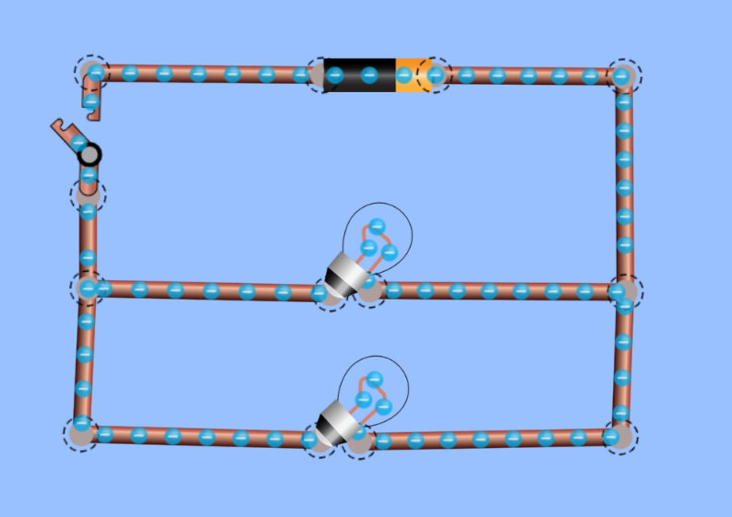
Part 3: Parallel Circuits
1
2
Step 7) Once you are ready, construct the circuit on the right. It has two lightbulbs in parallel. Set the battery to 60V and the resistance of the lightbulbs to 10 ohms each.
Step 8) Measure the potential difference and current of each lightbulb and the circuit. Record your results in Table 2.
Step 9) Add one more lightbulb with 10 ohms of resistance in parallel to the circuits and measure the voltage and current on each bulb then record them in Table 2.
Step 10) Lastly, add one more lightbulb with 30 ohms of resistance in parallel and record the measurements.
Table 2: Voltage and Current in a Parallel Circuit with up to Four Lightbulbs
 | Entire Circuit |  | Lightbulb #1 |  | Lightbulb #2 |  | Lightbulb #3 |  | Lightbulb #4
 | V_{tot} | I_{tot} | V₁ | I₁ | V₂ | I₂ | V₃ | I₃ | V₄ | I₄
Step 4  (2 bulbs) | 60 V | ____ A | ____V | ____ A | ____V | ____ A | N/A | N/A | N/A | N/A
Step 5  (3 bulbs) | 60 V | ____ A | ____V | ____ A | ____V | ____ A | ____V | ____ A | N/A | N/A
Step 6  (4 bulbs) | 60 V | ____ A | ____V | ____ A | ____V | ____ A | ____V | ____ A | ____V | ____ A

7. How does the speed of electron movement change when more lightbulbs are added in parallel?

8. How does lightbulb brightness change when more lightbulbs are added in parallel?

9. What is the relationship between the total current of the circuit and individual lightbulb currents in parallel?

10. What is the relationship between the total voltage of the circuit and individual lightbulb voltages in parallel?

11. How do you suppose electrical appliances are connected in our homes? In parallel or in series? Why?(Hint: What happens to other appliances when one appliance is turned off?)

12. A student is recording the following measurements on the table. Fill in the rest of the table and construct a circuit that is going to be aligned with the numbers on the table below. Then draw that circuit below.
V_{tot} (V) | I_{tot} (A) | R₁ (Ω) | V₁ (V) | I₁ (A) | R₂ (Ω) | V₂ (V) | I₂ (A)
 | 3 A |  | 12 V | 1 A |  | 12 V

