Names: ____________________________________________________________ Date: ____________________ Block: _________
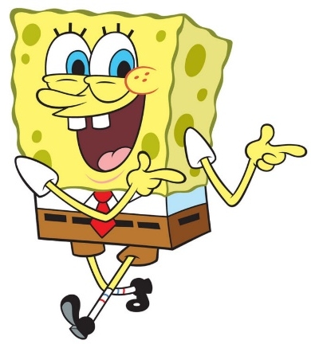
Porifera (Sponge) Lab

Display Specimens

- Sponges have asymmetrical body plans. Sketch two of the sponges on display to show their asymmetry. (1 mark)

- The sponges on display have a wide variety of shapes and textures. What do all of them have in common? What other observations can you make? (2 marks)

- Draw one of the two hard conical sponges on display. (3 marks)
On your drawing, label each of the following:
- Ostium (label at least two ostia)
- Mesohyl
- Osculum
- Draw arrows to indicate the direction of water flow in this conical sponge.

  - Sponges are in Kingdom Animalia, but they could easily be mistaken for plants. Why? List 1 characteristic that sponges and plants have in common (use the correct vocabulary) (1 mark)

  - Suppose you come across an organism while scuba diving and you want to find out whether it is a sponge or a plant. List 2 characteristics you would be able to observe in a sponge but not in a plant. (2 marks)

- Sponges have ‘totipotent’ cells.
  - What does ‘totipotent’ mean? (1 mark)

  - Briefly describe an experiment/test you could run to show that these cells are totipotent. (1 marks)

Microscope Handling Reminders:
- There are 4 magnifications: 40x (red, low), 100x (yellow, med), 400x (green, high), 1000x (white, oil). NEVER USE THE OIL LENS.
- Focus the slide on lower magnifications before moving to successively higher magnifications.
- If you cannot see the specimen anymore, STOP and check:
  - Is the specimen in the field of view?
  - If you still cannot see it, go to lower magnifications until you can find the specimen again. Make sure it is in focus before proceeding to higher magnifications.

Slide 1: Grantia spicules
On low magnification, adjust the focus until you can see what look like small cracks in the middle of the slide. Change to medium magnification and focus on these cracks, which are not cracks at all, but spicules!

- Draw several spicules. (1 mark)

- Explain why spicules are well suited to protect and support the sponge. (1 mark)

Slide 2: Grantia cross section and longitudinal section
Without changing the focus, change to this slide. Switch to medium magnification. The contents should already be close to being in focus. WITHOUT CHANGING FOCUS, move the slide left and right to find your specimen. It will be a very pale pink. When you have found it, focus using the fine focus knob.

- Find and draw an area of the sponge under medium or high magnification. Label choanocytes in your drawing. (2 marks)

- Are choanocytes on the interior or the exterior surface of the sponge? How do you know? Make a detailed drawing of a region of the sponge that supports your answer. (2 marks)

Small sponge | Large sponge

- Overall, the larger the sponge, the more complex its aquiferous system. Large sponges have many more channels and chambers than a small sponge. Why do you think this is? (1 mark)

