Name: _________________________________________ Date: ________________________

**Static Electricity Lab (Science 9 Pathways)**

***Pre-lab Questions***

Answer the following questions before proceeding.

1. How does something become positively charged?
2. How does something become negatively charged?
3. What is a neutral object?
4. How can a charged object become neutral?

1. If you rub glass with wool, which one will become positively charged? Which will become negatively charged? (Use the electrostatic series figure from pg. 276 of your textbook to help you).

***Activity 1: Balloon***

Materials:

* Rubber balloon
* Wall
* Hair (or wool cloth)

Questions:

1. Vigorously rub the rubber balloon on your hair (or wool cloth) for 5-10 seconds. Hold it against the whiteboard. What happens?
2. When you rubbed the rubber balloon, did it become positively or negatively charged? How do you know?
3. How did the charged balloon stick to the neutral wall? Explain, using a diagram.
4. Predict the charge on the balloon if you had rubbed it with cotton. (Would it be positive or negative? Would the charge be greater or lesser than when you rubbed with wool?)
5. Predict what would happen if you had rubbed the balloon for a longer time. Would it stick to the wall for a longer or shorter time? Explain.
6. Predict what would happen if you had rubbed the balloon with a piece of metal instead.

***Activity 2: Induced Charge Separation***

Materials:

* Ebonite
* Glass
* Wool
* Hole punches (small pieces of paper)

Questions:

1. Explain how a charged object can attract a neutral object, using a diagram. What is the term for this?
   1. If you rub ebonite with wool, what will the charge on the ebonite be?
   2. If you rub glass with wool, what will the charge on the glass be?
2. Make a small pile of hole punches on the table. Rub a piece of ebonite with wool vigorously for 5-10 seconds, then bring the ebonite close to the hole punches. What happens?
3. Rub the ebonite vigorously with wool for 5-10 seconds, then bring the ebonite close to a small but steady stream of running water. What happens? Why? (You may have to do extra research into the electrical properties of water).
4. Repeat steps #3 and #4, except with the glass rod. What happens?
5. Explain how two oppositely charged rods can have the same effect on water and pieces of paper.

***Activity 3: Electroscope***

Materials:

* Electroscope
* Glass, ebonite, or other easily chargeable rod
* Wool or cotton cloth

Questions:

1. Charge the electroscope by induction and observe what happens to the leaves when the charged rod is brought near. Then, remove the rod and observe what happens.
2. Charge the electroscope by conduction and observe what happens to the leaves when the charged rod touches the metal dome. Then, remove the rod and observe what happens. Do your observations fit with your expectation? Explain.
3. Compare and contrast charging by conduction with charging by induction.

***Activity 4: Van de Graaff Generator***

1. A key part to the safe handling of a Van de Graaff generator is the discharge wand. It consists of a steel sphere mounted on a plastic rod. Why is the handle made of plastic?
2. Explain why the discharge wand must be connected through a wire to a metal sink which is connected to the ground.

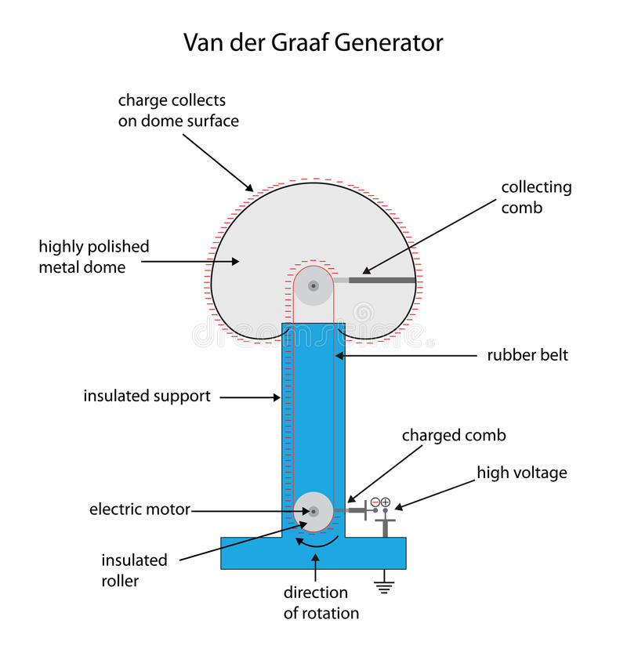

1. What happens when the generator is turned on? How does static charge build up on the metal dome?
2. Explain what happens when the discharge wand is brought near the charged dome (while the generator is running). Why does this occur?
3. Explain what happens when metal plates are stacked atop the generator and it is turned on. Why does this occur?

Extending Questions:

1. EXT: How does humidity affect static electricity? Does a high humidity increase or decrease the effects of static electricity? Explain why.

Investigate how and why lightning strikes occur.

What are some ways you can avoid getting electrocuted when you are out in stormy weather? List three.

Instructions:

1. Make a small pile of hole punches on the table.
2. Rub a piece of ebonite with wool vigorously for 5-10 seconds.
3. Bring the ebonite close to the hole punches and observe what happens.

Rub a piece of ebonite with wool.

What is the charge on the piece of ebonite?

When you bring the charged wool close to small pieces of paper, what happens?

When you bring the charged wool close to a small stream of water, what happens? (You will have to do some research about the properties of water to answer this question).

Explain how two oppositely charged rods can have the same effect on water and pieces of paper.

Rub a piece of glass with wool.

Concepts:

* Law of electric charges
* Static charge
* Discharge
* Lightning
* Electrostatic series
* Induced charge separation (attraction of neutral objects to charged objects)
  + E.g. charged object and paper scraps
  + E.g. charged object and water stream
* Charging by friction (rubbing. Positive and negative charges in equal quantities)
* Charging by conduction (touching a charged object to an uncharged object; the charge moves over)
* Charging by induction (charging an object without touching or direct contact between the objects
* Insulators
* Conductors
* Grounding
* Electroscope and how it works (induction AND conduction)
* Van de Graaf generator
  + <https://www.youtube.com/watch?v=hoswNJZqUX0&ab_channel=JeffersonLab> bubbles

A definition of the word “static” is “lacking in movement, action, or change”. Explain why static electricity is named the way it is.

How does something become positively charged (in terms of its protons, neutrons, and/or electrons)?

How does something become negatively charged (in terms of its protons, neutrons, and/or electrons)?

What is a neutral object?

How can a charged object become neutral?

Materials:

* Ebonite

Materials:

* Rubber balloon
* Wall
* Hair (or wool cloth)

Vigorously rub the rubber balloon on your hair (or wool cloth) for 5-10 seconds. Hold it against the whiteboard and observe what happens.

When you rubbed the rubber balloon, did it become positively or negatively charged? How do you know?

How did the charged balloon stick to the neutral wall? Explain, with a diagram showing the charges on both, and how the charges move.

Predict the charge on the balloon if you had rubbed it with cotton. Would it be positive or negative? Would it be ***more or less*** strongly charged? Would it stick to the wall for a longer or shorter time?

Predict what would happen if you had rubbed the balloon for a longer time. Would it stick to the wall for a longer or shorter time? Explain.

Predict what would happen if you had rubbed the balloon with a piece of metal instead.

<https://www.scientificamerican.com/article/bring-science-home-static-electricity-attraction/#:~:text=However%2C%20because%20metal%20is%20an,attracted%20and%20does%20not%20adhere>**.**

**Materials**  
•    Balloon  
•    An object made out of wool (such as a sweater, scarf, blanket or ball of yarn)  
•    Stopwatch  
•    A wall  
•    A partner (optional)  
  
**Preparation**  
•    Blow up the balloon and tie off the end.  
•   Have your partner prepare to use the stopwatch.  
  
**Procedure**  
•    Hold the balloon in a way that your hand covers as little of its surface area as possible, such as by using only your thumb and pointer finger or by gripping the balloon by its neck where it is tied off.  
•    Rub the balloon on the woolly object once, in one direction.  
•    Hold the balloon up on the wall with the side that was rubbed against the wool facing the wall, then release it. Does the balloon stay stuck on the wall? If the balloon stays stuck, have your partner immediately start the stopwatch to time how long the balloon remains bound to the wall. If the balloon does not stick, move to the next step.  
•    Touch the balloon to a metal object. Why do you think this is important to do?  
•    Repeat the above process but each time increase the number of times you rub the balloon on the woolly object. Rub the balloon in the same direction each time. (Do not rub the balloon back and forth.) How many rubs does it take to make the balloon stick to the wall for a few seconds? What about multiple minutes?  
•    You can repeat this whole process two more times. Do your observations for each trial match with the previous trials?  
•    **Extra:** Does rubbing in one direction give a different result than rubbing back and forth? Try comparing the same number of rubs in one direction with those done back and forth. Does one stay on the wall longer than the other?  
•    **Extra:** Try comparing the effectiveness of different materials for producing a static charge. Does rubbing wool work better than rubbing silk? Design an experiment to test several different materials: silk, wool, nylon, polyester, plastic, metal, etcetera.  
  
**Observations and results**  
In general, did the balloon stick to the wall for a longer amount of time as you increased the number of times you rubbed the balloon on the woolly object?

Wool is a conductive material, which means it readily gives away its electrons. Consequently, when you rub a balloon on wool, this causes the electrons to move from the wool to the balloon's surface. The rubbed part of the balloon now has a negative charge. Objects made of rubber, such as the balloon, are electrical insulators, meaning that they resist electric charges flowing through them. This is why only part of the balloon may have a negative charge (where the wool rubbed it) and the rest may remain neutral.

When the balloon has been rubbed enough times to gain a sufficient negative charge, it will be attracted to the wall. Although the wall should normally have a neutral charge, the charges within it can rearrange so that a positively charged area attracts the negatively charged balloon. Because the wall is also an electrical insulator, the charge is not immediately discharged. However, because metal is an electrical conductor, when you rub the balloon against metal the extra electrons in the balloon quickly leave the balloon and move into the metal so the balloon is no longer attracted and does not adhere.

Rub a piece of ebonite with wool.

What is the charge on the piece of ebonite?

When you bring the charged wool close to small pieces of paper, what happens?

When you bring the charged wool close to a small stream of water, what happens? (You will have to do some research about the properties of water to answer this question).

Explain how two oppositely charged rods can have the same effect on water and pieces of paper.

Rub a piece of glass with wool.

How does humidity affect static electricity? Does a high humidity increase or decrease the effects of static electricity? Explain why.

According to healthline.com, some solutions for static in hair are:

* Apply face moisturizer to static strands
* Using your fingertips to smooth water over your hair

Explain how these would decrease the amount of static electricity in your hair. (original article: <https://www.healthline.com/health/how-to-get-rid-of-static-from-hair>)

Charge a rod with another object. Bring it close to small pieces of paper and observe what happens. What happens to a piece of paper after it is initially attracted to, and sticks to, the rod? Explain this observation with charges and the movement of charge.

Compare and contrast charging by conduction, and charging by induction.

How does the electroscope work? Explain in your own words.

Design a demonstration using the electroscope to demonstrate charging by induction. Design a demonstration using the electroscope to demonstrate charging by conduction.

Van de Graaff Generator

A key part to a successful Van de Graaff demonstration is the grounding rod. Draw and label a diagram of the grounding rod.

Why is the handle of the grounding rod made of plastic?

Explain why the grounding rod must be connected through a wire to a metal sink which is connected through insulators to the ground.

Explain what might happen if the grounding rod were not connected in this way.

Draw and label a diagram of the Van de Graaff Generator.

What happens when the generator is turned on? How does static charge build up on the metal dome?

Explain what happens when the generator is turned on and the grounding rod is brought near to it. Why does this occur?

Investigate how and why lightning strikes occur.

What are some ways you can avoid getting electrocuted when you are out in stormy weather? List three.

Explain what happens when someone is holding on to the generator when it is turned on. Why does this occur?

Explain what happens when metal plates are stacked atop the generator and it is turned on. Why does this occur?