Science 9: Review of Subatomic Particles and Bohr Models
Atom: ____________________________________________________________________________________________
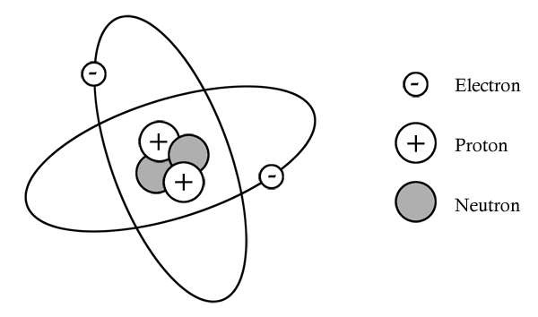
- Proton: ______________________ charged particle in the _________________ of an atom; has a mass of ______.
- Neutron: _______________________ particle in the ____________________ of an atom; has a mass of ______.
- Electron: ________________________ charged particle in _________________________________ surrounding the nucleus of the atom; very ______________ (mass of ______________).

 | Number of Protons (p) | Number of Neutrons (n) | Number of Electrons (e)
Atom

3) Complete the following table.
 | protons | neutrons | electrons
Al
Mg
B
Ti
Ca
F
Cl
Ar
Zn
Practice:
- Why do atoms have the same number of protons and electrons?
_______________________________________________________
_______________________________________________________

- Explain why you need to subtract atomic number from atomic mass to calculate the number of neutrons in an atom.
_______________________________________________________
_______________________________________________________
_______________________________________________________
______________________________________________________
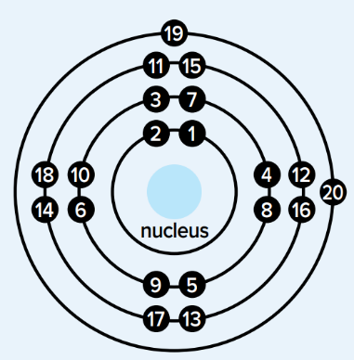
Bohr Models of Atoms
- Calculate the number of protons, neutrons, electrons.
- In the nucleus:
  - _________________________________________
  - _________________________________________
- Draw the electrons in energy shells:
  - Max electrons per shell from inside to outside: _______________________________
  - (Except in first shell), electrons are filled starting at top, going clockwise, singly at first then paired

Example: sodium atom | Example: oxygen atom

Science 9: Valence Shells and Ions
Valence Shells and Valence Electrons:
- Valence shell is the outermost shell containing electrons
- Valence electrons are electrons in the valence shell

- Atoms in the same group have the same number of _______________________________________.
- Atoms in the same period have the same number of ________________________________________.
During a chemical reaction, atoms _____________________________________ valence electrons with other atoms until they have _____________________________.
___________________________ are unreactive because their valence shells are already full.
Ion: a charged ‘atom’ that is formed when a neutral atom _______________________ electrons
Cation: _______________________ charged ion (e.g. Ca²⁺, Na⁺), formed when atom loses electrons
Anion: _______________________ charged ion (e.g. O²⁻, P³⁻), formed when atom gains electrons
Bohr models of ions are very similar to Bohr models of atoms. Two key differences:
- Valence shell is full
  - (Note: the fewer electrons that have to move, the better. E.g. oxygen with 6 valence electrons will gain two electrons to form its 2- ion instead of losing six electrons.)
- Square brackets and ion charge
Examples: Draw the Bohr models of fluorine and magnesium atoms and their ions.
Fluorine | Beryllium
Practice:
- Explain why metals tend to lose electrons and non-metals tend to gain them when forming ions.

- On your periodic table, the ion charge of neon is listed as “0”. Why is this the case?

- On the back of this page, draw the Bohr models of: a) oxygen atom and ion; b) magnesium atom and ion; c) nitrogen atom and ion; d) chlorine atom and ion

