Names: ___________________________________________ Date: __________________ Block: _______
Project Due Date: _____________________________________________________________________________
Taxonomy/Phylogeny Project (LSci11)
Stage 1: Research (Note: You are required to cite sources for 3b only.)
- Select a focal species of your choice. Write the common name and Latin name of this species.
- Research. Which taxa does your species belong to? (Domain, Kingdom, Phylum, Class, Order, Family, Genus, Species)
- For each taxon:
  - Determine other representative examples of species in that taxon.* Write the common names and Latin names of those species.
    - Genus: 1 example
    - Family, Order, Class, Phylum: 2 examples each
    - Kingdom and Domain: 3 examples each
  - Research 3 unique, defining traits of species in that taxon. List them.

Stage 2: Poster
Design a poster as a visual representation of your research into how your focal species is classified. The actual design of your poster is up to you, but it should show a ‘nested’ arrangement of the taxa, with Domain being the largest and Species being the narrowest. Suggestions: concentric shapes, pyramid.
Each of your 16 species will have the following:
- Common English name
- Latin name with proper binomial nomenclature formatting
- A colour picture
Category | Description | Points Available
Overall Organization and Presentation | - Poster is well-organized, neat, and colourful.  - Taxa can clearly be distinguished from each other. Taxa are ‘nested’ in the correct order (i.e. larger taxa ‘include’ smaller taxa).  - Each taxon title is listed alongside the taxon itself (i.e. “Domain Eukarya” instead of just “Eukarya”). They are spelled correctly.  - Each species can be easily matched with its common name, Latin name, and drawing.  - Words have been spelled correctly. | /8
Species | - The correct number of species per taxon is included.  - Species are good representative examples of that taxon.  - Each species has a common name, properly formatted Latin name, and colour picture.  - Pictures of species are clear, with key features easily recognizable. Pictures are in colour. | /8
Total |  | /16
Stage 3: Phylogenetic Tree
Make a phylogenetic tree as a visual representation of how your species evolved. This tree will represent the taxa that your focal species belongs to and will map the key characteristics (a.k.a. derived traits) of each taxon. Since phylogenetic trees are meant to show the relationships between species, not taxa, you will select one representative species from each taxon and map that onto your tree.

Category | Description | Points Available
Phylogenetic Tree | - Phylogenetic tree is neat and organized.  - Phylogenetic tree has been properly formatted.  - Tree has a root.  - Branches split from nodes.  - Derived traits have been plotted in their appropriate locations along the branches.  - Species are placed at the ends of branches.  - One representative species is shown for each taxon (8 in total). Each species is indicated by its common name, and its Latin name in binomial nomenclature. Pictures of species are not required. | /3
Taxonomical Research | - 3 unique characteristics (a.k.a. derived traits) of each taxon have been appropriately researched and listed.  - Writing is easy to read and understand. Spelling and grammar are correct.  - “I get it, and I don’t need to Google the hard words.” A reasonable attempt* has been made to word characteristics simply, in a way that can be understood by an average gr 11 science student. Definitions or labelled images are included where relevant, to help with this.  - Example: If “plantigrade paws with five non-retractile claws” is one of your characteristics, you could include a diagram to show what plantigrade means, and explain the meaning of non-retractile.  - *Note: You are not expected to become an expert on every taxon. However, you should dig deeper on the characteristics you have chosen and try your best to understand them. As a general guide, you should explain characteristics of all taxa “Family” and higher. Exceptions can be expected for “Genus” and “Species” since those characteristics are likely to be highly technical in nature. Consult your teacher prior to the due date if you have questions. | /12
Citations  (Projects submitted without citations will not be marked.) | - All sources of information and images have been cited. A formal bibliography is not required. It is acceptable to copy and paste links.  - Citations are well-organized. It is easy to find the link to a specific picture or piece of information. (Recommendation: organize your citations by taxon or species.) | /3
Bonus | - Other species (up to 2) have been placed in their appropriate locations on the phylogenetic tree, with derived traits also in appropriate locations to distinguish them from closely related species. | /2
Total |  | /18

Final Note: At the end of the project, group members have the option of completing a peer evaluation. Final project marks may be scaled to reflect relative contribution in groups where work was very unequally distributed.

Tips for Picking Representative Species
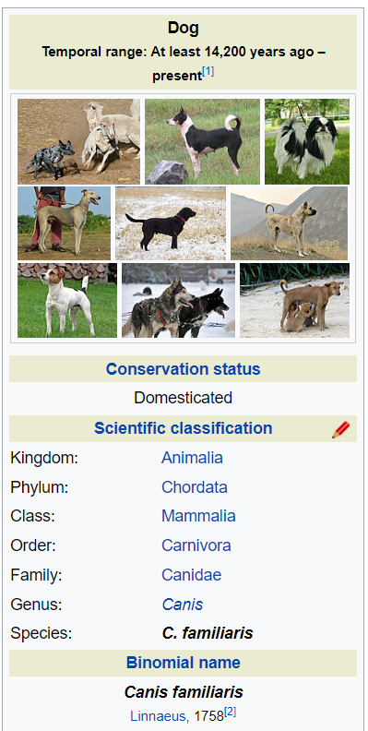
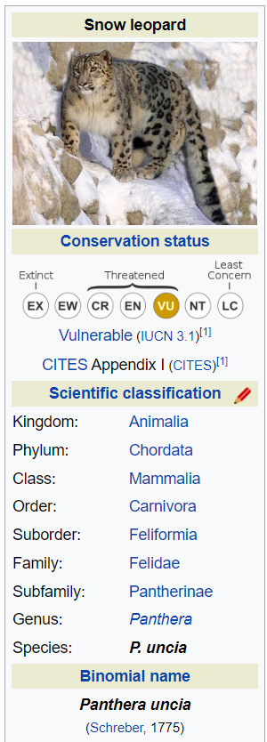
- Try to pick species that are most representative of the taxon as a whole, especially with the larger taxa.
  - E.g. “Chordata” includes all organisms with a backbone.
    - Good example: a fish, a frog, and a tiger
    - Bad example: three different kinds of fish
- Use examples as closely related as possible.
  - E.g. Snow leopard and dog have many taxa in common: Domain, Kingdom, Phylum, Class, Order. Their family is different. If “Snow Leopard” is the species you are using for your poster, then “Dog” should be used as an example for Carnivora, since this is the last taxon they share. Dog should not be used as an example of Mammalia, Chordata, Animalia, or Eukarya.

